Grim Portents 1: The Dead of Winter
Table of Contents
Foreword 2
The Fourth Page: Monsters 4
Put Myself in Danger? Sure, Why Not? 5
The Engine of Destruction 6
The Necromancer 11
The Warrior 15
The Miscellany 20
The Compendium of Classes 21
Monsters 24
Templates 27
Companions 29
Gnomes 30
Extraplanar Races 32
The Rythbjörn 34
Tower of Dosdaemon 38
Extracts from Stone & Shadow 49
World of Dungeon Crawls 53
Attribution 55

About Grim Portents
This is the first issue of Grim Portents, a fan zine for the Dungeon World tabletop roleplaying game. It was edited by Chris Sakkas and released in April 2013.
Release 1. For updates and new issues, see Living Libre.
Thank you so much to the authors who contributed articles: Adam Koebel, Mike Riverso, Kasper Brohus Allerslev, Johnstone Metzger, Giovanni Lanza, John Ryan, Scott Velez, Marshall Miller, Parker D Hicks, Jeremy Friesan, Jeremy Strandberg, Alexander Davis, At the Table Games, Kingston Cassidy, David Guyll, Matthew Gagan, Bill White and Chris Bennett.
Many of these contributors also proofread and edited the contributions of others.
Thank you also to the artists who contributed illustrations: Michael Wight, Giovanni Lanza and Nate Marcel.
This issue also uses pre-existing artworks from Open Game Art, Prismatic Art, Flickr and Wikimedia Commons. For a more detailed attribution of artworks, see the last page of this zine.
The cover was created by Jonathan Walton of Corvid Sun.
The layout template was designed by Raoni Monteiro. The theme of this issue, The Dead of Winter, was suggested by Jeremy Friesen of Take on Rules.

Art and Licensing
Sage LaTorra and Adam Koebel made the brave and generous decision to license Dungeon World under the Creative Commons Attribution licence. That made this zine possible.
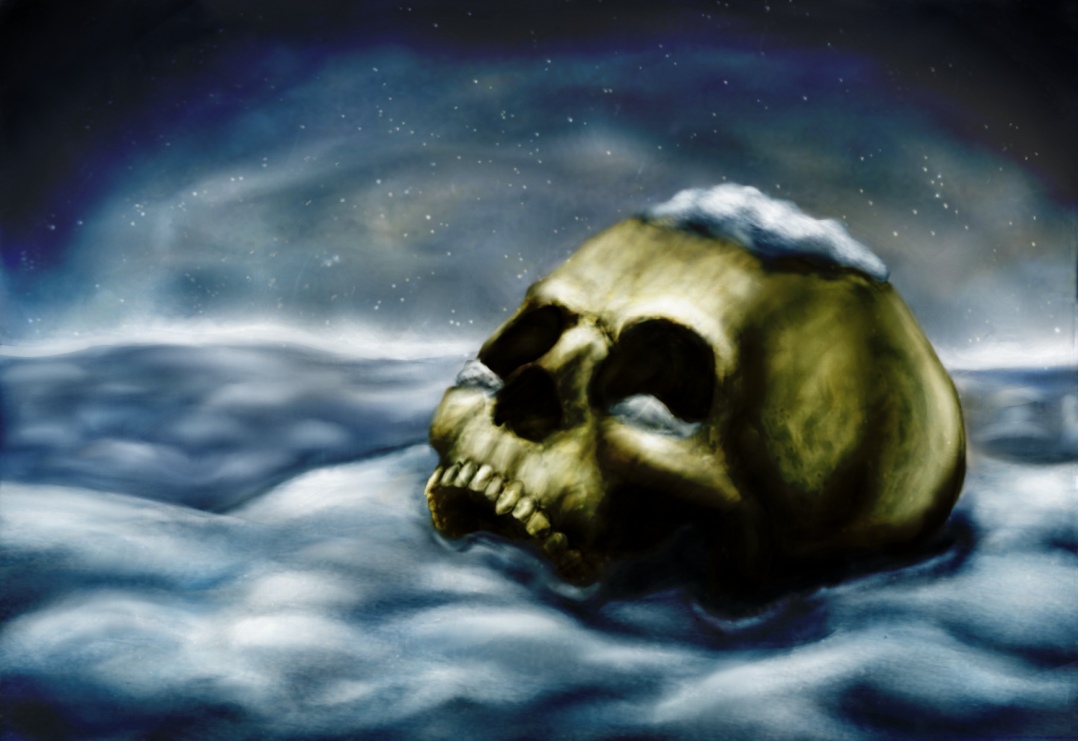
As a compilation, Grim Portents issue 1 is released under the Creative Commons Attribution-ShareAlike 3.0 Unported License. That means you are free to share and adapt it for any purpose, provided you keep all duplicates and derivatives under the same Creative Commons Attribution-ShareAlike licence.
Individual contributions to Grim Portents issue 1 may be under the more liberal Creative Commons Attribution 3.0 Unported License. See the last page for more details.
If you are interested in Creative Commons licences and other forms of free culture, open source and intellectual property minimalism, Chris Sakkas has a blog called Living Libre.

Contributing to Grim Portents
We accept written contributions, illustrations, editing assistance, layout assistance and donations. To contribute, get in touch with Chris Sakkas at sanglorian@gmail.com

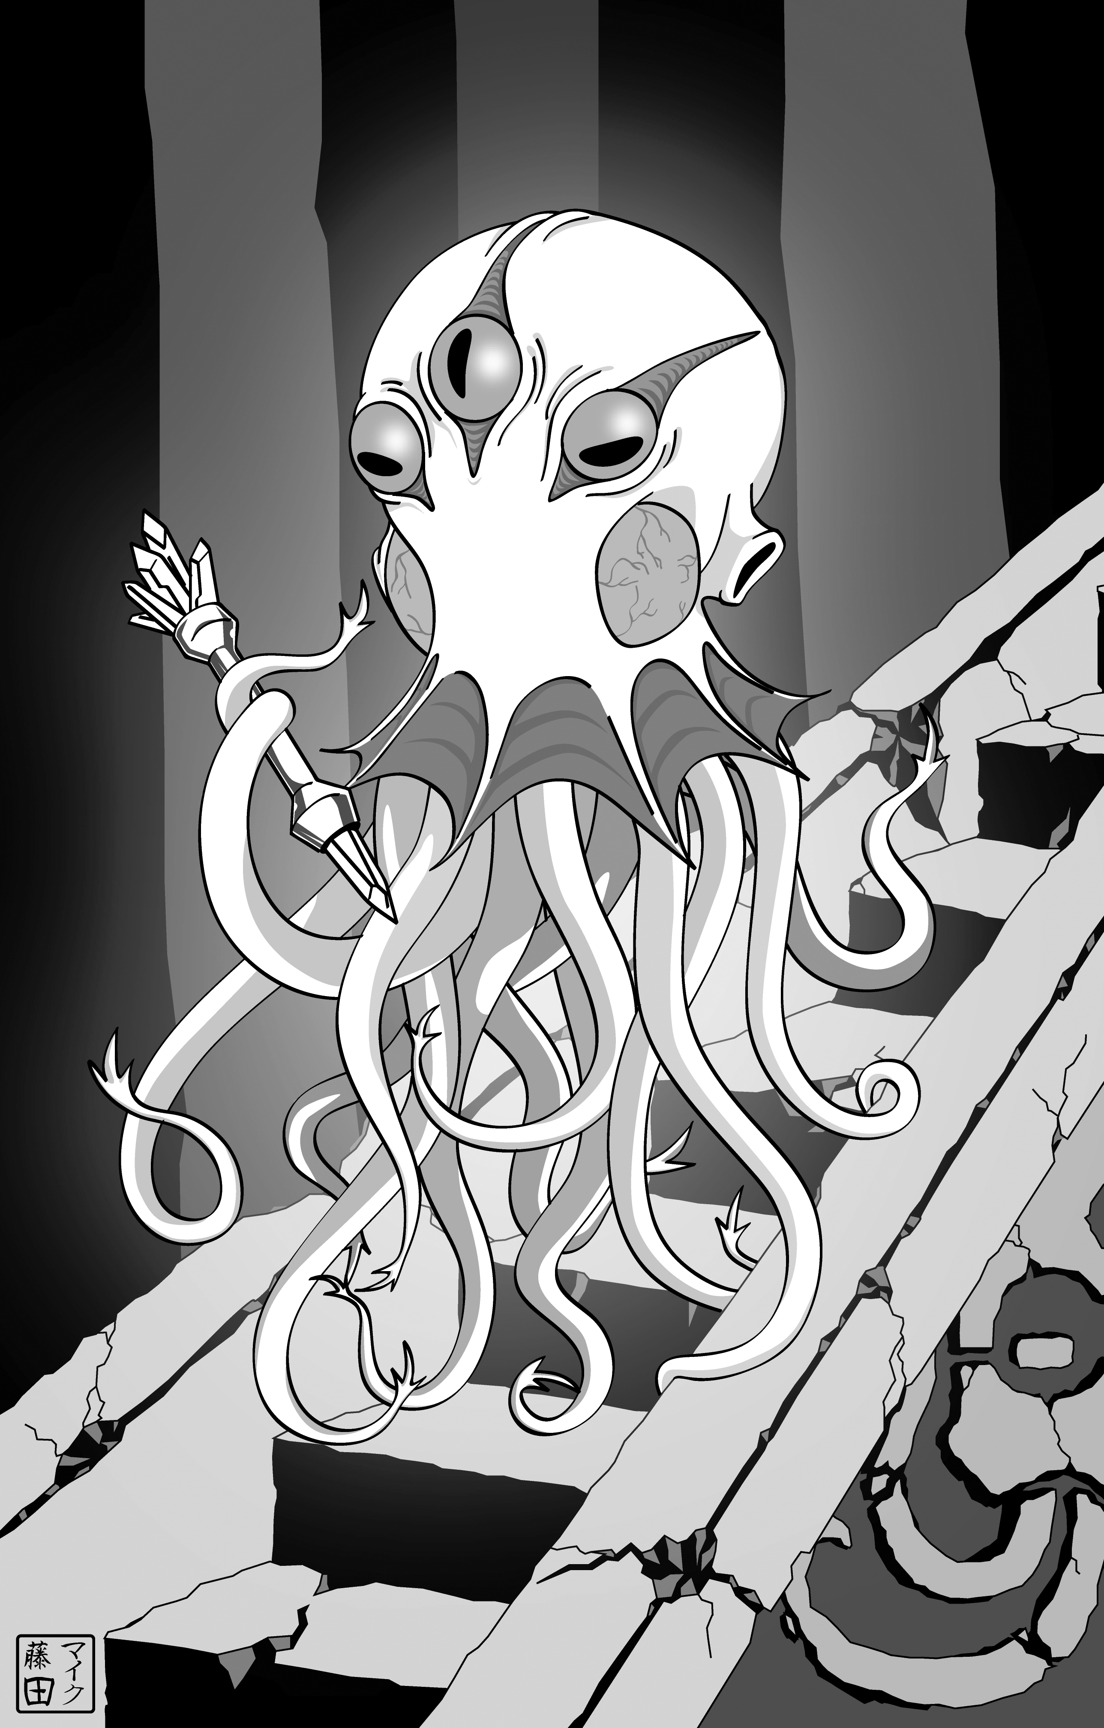
Foreword
I used to be one of those by-the-book game fans. I only wanted to use"official" supplements and if anyone suggested anything that even smelled a little like "house rules" they’d get an eye-roll from me. For some reason, during this period in my gamer-history, I figured that if something was any good, some big ol’ game company would bless it with their seal of approval. I’d have bought it from the dude behind the counter at my semi-friendly local game store, right?
If it’s not self-evident, I don’t believe that any more. At some point, the line between "official" and "fan supplement" blurred so hard that it just stopped mattering. Tabletop gaming exists in a space, now, where the best stuff is made by people who are passionate and who, you know, read and play games. People get together and bash out the most amazing, inspired material just by taking their favourite game and asking themselves what they can do to make it their own. Every hack and mod and module is a love letter. I suppose that was always true, but because we have the tools to collaborate better than we did before (Twitter, Google Plus, Forums, Dropbox, GitHub, internet internet internet) we can take that sweet step from house rules for our basement games out into the open world. We can be both fan and creator at once.
Sage and I wrote Dungeon World to be one of those love letters. To old-school fantasy and to modern design. To narrative and to awe and to play that feels like the first time we cracked our Player’s Handbook. It would have been remiss (or, hell, even a little disingenuous) of us to pretend that we weren’t standing on the shoulders of the game designers who came before us. So it only seems right that we made the game as open as possible to folks who want to do the same. Hence the license being the way it is. Hence the encouragement to go and do cool stuff with what we made. We’re seeing Dungeon World supplements appear out of nowhere, built on forums, crafted on Twitter, tested on Skype and dispersed with the same efficiency (and often on the same platforms) as the official game. It’s magic and we love it.
You’re looking at the first issue of what I hope will be a long-standing tradition for Dungeon World. Fan-zines have always been a fantastic place to see what people are doing with the rules they’re given. We’re damn lucky to live in an age where it’s easier to share that material than ever before. Every time someone does something with DW that we would never have thought of, it hammers home the creativity of the fanbase of our game (and the whole hobby in general).
I hope there’s something in these pages that inspires you to share the cool stuff you’ve got going on in your head. Write your own love letter. Get excited and make things.
Adam Koebel

The Fourth Page: Monsters
An idea generator for World of Dungeons and other fantasy games by Mike Riverso
Nature
1. Animal and Plant
- Its barbs are filled with poison.
- You’re entangled in its web.
- They travel in packs.
- It’s hunting you.
- Teeth and claws rend and tear.
- The place is swarming with them.
2. Construct
- They fight with mindless perseverance.
- They repair their own injuries.
- It’s disguised as a mundane object.
- You’re walking through its hallways.
- It’s immune to your usual tricks.
- Its patterns are predictable.
3. Elemental
- Fire burns your flesh.
- You’re blown away by air.
- The earth shakes, rocks fall.
- Water freezes and drowns you.
- You’re seared by blinding light.
- Your world is plunged into darkness.
4. Humanoid
- Their traps and nets ensnare you.
- Their primitive magic is surprisingly effective.
- They’re simply misunderstood.
- You’ve offended them.
- They wield strange devices.
- They’re a motley crew.
5. Mythical Beast
- Its breath is worse than its bite.
- It’s greater than the sum of its parts.
- You’ve encroached on its lair.
- Its hide is worth a fortune.
- Its appearance is an ill omen.
- Its magics are beyond your ken.
6. Undead
- Their howls make you tremble in fear.
- They remember their former lives.
- Their touch drains your life force.
- They just won’t stay down.
- They carry terrible disease.
- They phase through solid objects.
Role
1. Artillery
- They shoot at you from cover.
- You’re caught in the blast radius.
- They’re aware of your approach.
- They fall back when threatened.
- You’re trapped by suppressing fire.
- They use unusual ammunition.
2. Brute
- It knocks you down.
- It gets in your way.
- It goes berserk.
- It tramples you.
- It wrecks the place.
- It cuts a wide swath.
3. Controller
- Their charms confuse you.
- The terrain turns treacherous.
- It counters your magic.
- It’s all an illusion.
- They surround you from all sides.
- It disarms you.
4. Leader
- He heals his allies.
- She inspires her minions to fight.
- His extended monologues are tedious.
- Its master plan is inscrutable.
- There is a method to his madness.
- She leads the charge.
5. Lurker
- You don’t see the sneak attack coming.
- It blends in with the surroundings.
- They dart just out of reach.
- It’s literally invisible.
- They’re actually enjoying this.
- It waits for just the right moment.
6. Soldier
- They’re careful in their approach.
- They’re well-armed and well-armoured.
- Their teamwork puts yours to shame.
- They’ve been forced to fight.
- They defend their weaker allies.
- They outnumber you.

Put Myself in Danger? Sure, Why Not?
An article by Kasper Brohus Allerslev from http://partialsuccess.wordpress.com
A lot of the moves in Dungeon World have some slight drawbacks on a partial success (result of 7–9), the most common one being that you can “draw unwanted attention”
This might not seem like a big deal, but there are actually a lot of ways to use this as a GM. A good way of doing this can be to save a player's hide.
Imagine Grobrek, the dwarf fighter, swinging savagely with his axe at a demon overlord. They take swings at each other, and after some time Grobrek is reduced to 2 HP. Now, death is an imminent threat, so Haldir, the elven bard, decides to weave a healing spell into a small performance with his flute, healing d8 damage on Grobrek.
Haldir rolls and gets a total of 8. Now, the GM can either choose to reverberate the effects to other targets—the demon, for example—or he can choose to have Haldir “draw unwanted attention”.
Seeing that Haldir has 18 HP left, the GM decides that a good way to make the game interesting wouldn’t be to heal the demon, but to let it loose on Haldir, cutting Grobrek some slack. The demon flaps its wings, evades a blow from Grobrek and lands besides Haldir, grabs him by the neck and lifts him from the ground.
“What do you do?”
We have just used a “consequence” of a partial success to save a player character. Now the bard is in trouble, but hopefully his friends will come to his aid!

The Engine of Destruction
A class by Johnstone Metzger
Cold, logical, inhuman: this is what they assume, and perhaps they are right. A powerful thinking machine you are, built to roam across planets unimpeded, built for war, built for science! You are not weak like these humans, you are impervious, immortal; a truly sustainable being. What need have you for air and water and children? The whole vast universe lies before you, and there is no world now that can deny you trespass.
You are a robot, created to fulfill a great need, programmed with a mission of the utmost importance. Is this still your driving force or have you grown, reprogrammed yourself and found a new purpose? For once you build a machine that thinks, it thinks for itself.
The engine of destruction is an alternative version of the fighter, designed for weird science fantasy adventures. The engine of destruction can make a good ranged fighter, infiltrator, or information gatherer: play one if you want to wreck things and employ an array of gadgets.
Names
Andromeda, Ash, Call, Coppélia, Daneel, Destructor, Futura, Ilia, Klapaucius, Olympia, Pris, Robbie, Sulla, Zed
Look
Choose one for each:
Glowing “Eye(s)”, Human Eyes, or Many Eyes.
Computer Voice, Human Voice, or Inhuman Voice.
Metal Exterior, Plastic Exterior, or Synthetic Skin.
Humanoid Shape, Vehicular Shape, or Weird Shape.
Stats
Your maximum HP is 10+Constitution
Your base damage is d10.
Starting Moves
Choose a specialization and gain the corresponding move:
Scientific Exploration Robot
When you discern the realities of non-living matter and energy, you can roll with INT instead of WIS.
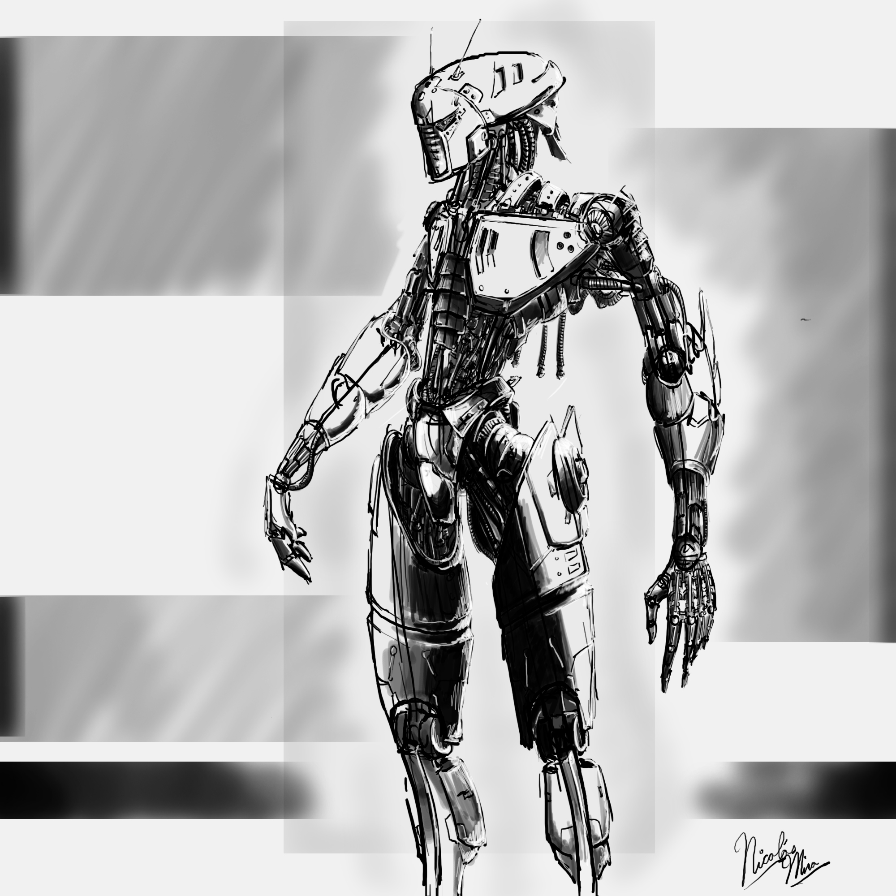
Seek and Destroy Unit
When you use your built-in weapons, you can roll with STR to volley instead of DEX.
Tank
You have a heavy, reinforced metal exterior (2 armor, implanted, 2 weight) to protect you from harm.

You start with these moves:
Automatic Systems
You have various mechanical functions built into your robot body. Choose three:
- Drug injectors (applied): You have anesthetic and one thief poison of your choice
- Extendible limbs: Add reach and near to your melee attacks
- Flame thrower (reach, ignores armor, messy, reload) and gas (3 ammo)
- Force field: Gives you 2 armor when turned on
- Lasers (near, far, 1 piercing): You take 1d6 damage instead of expending ammo
- Projectile cannon: Makes any hand-held object a thrown weapon (near, far)
- Stun-wave projector (near, ignores armor, stun)
- Suspensor arrays: You can hover and slowly levitate
- Utilities: You have an endless array of gadget utilities, from a portable kitchen and film projector to interior storage space, radio communication and spot lighting
- Weaponized: With metal fists and implanted blades (close), you do +2 damage in melee
Bend Bars, Lift Gates
When you use pure strength to destroy an inanimate obstacle, roll +STR. ✴ On a 10+, choose 3.
✴ On a 7–9, choose 2.
- It doesn’t make an inordinate amount of noise.
- It doesn’t take a very long time.
- Nothing of value is damaged.
- You can fix the thing again without a lot of effort.
From the Ashes, a Titan Arises
When you lose all your hit points, you don’t roll for your last breath; the one who rebuilds or repairs you does, and deals with Death on your behalf. If they are a scientist or technician, they can roll +INT.
Welcome to the Machine
When you make camp, you don’t consume rations and you don’t sleep (or heal HP like others).
When you consume fuel in order to restore lost hit points, roll +CON. ✴ On a 10+, you have enough to repair yourself fully. ✴ On a 7–9, you can restore half your lost hit points, but you need something else to finish the job. The GM will tell you what. ✴ On a miss, you consume all your fuel to no avail: you must have more!

Alignment
Choose your programming:
Lawful
Perform, under duress, the specific job or work you were created to do.
Good
Provide humans with wealth and riches or helpful technological devices.
Evil
Deliver suffering unto intelligent, organic life forms.
Gear
Your load is 12+STR. Choose up to two of the following:
- 2d6 coins
- Bag, box, or case
- Clothes
- Holographic recorded message
Bonds
Fill in the name of one of your companions in at least one:
_______________ helped get me repaired when I was broken.
_______________ knows a secret about my construction!
_______________ understands me perfectly, even though I am a robot.
I was programmed to help _______________.
Advanced Moves
When you gain a level from 2–5, choose from these moves.
Automated Targeting Systems
When you wound a living, organic enemy, your next attack against the same foe deals +1d4 damage.
Cannibalized Technology
When you have access to the proper tools, you may install technological devices into yourself. Instead of this technology existing as a separate unit, it is now a functional part of your robot body.
Change of Face
You have synthetic skin that can be modified to make you look like a range of human beings. You can mimic another person’s physical features but not their behaviors and mannerisms. Choose one feature that persists no matter what your face looks like.
Environmental Sensors
When you use your sensors to study the natural or supernatural influences at work in the environment, they tell you what forces are at play in your location (especially arcane or divine forces), roll +INT. ✴ On a 10+, the GM will give you good detail. ✴ On a 7–9, the GM will give you an impression.
Fully Loaded
You get another two automatic systems functions.
Iron Hide
You have +1 armor.
Mechanical Objectivity
When you analyze a creature’s behavior with your computer brain, roll +INT. ✴ On a 10+, ask the GM 2 questions from the list below. ✴ On a 7–9, ask 1:
- How can I exploit or protect them?
- What do they need right now?
- What will they do next?
- Where can I find them?
Merciless
When you deal damage, deal +1d4 damage.
More Human than Human
Get one move from another class. Treat your level as one lower for choosing the move.
Versatile Utility
Choose a second specialization move (now you have two).
Zardoz Speaks to You
When you parley using threats of impending violence as leverage, you may roll with STR instead of CHA.
When you gain a level from 6–10, choose from these moves or the level 2–5 moves.
Assimilated
Requires: More Human than Human
Get one move from another class. Treat your level as one lower for choosing this move.
Bloodthirsty
Replaces: Merciless
When you deal damage, deal +1d8 damage.
Calibrated Targeting Adjustments
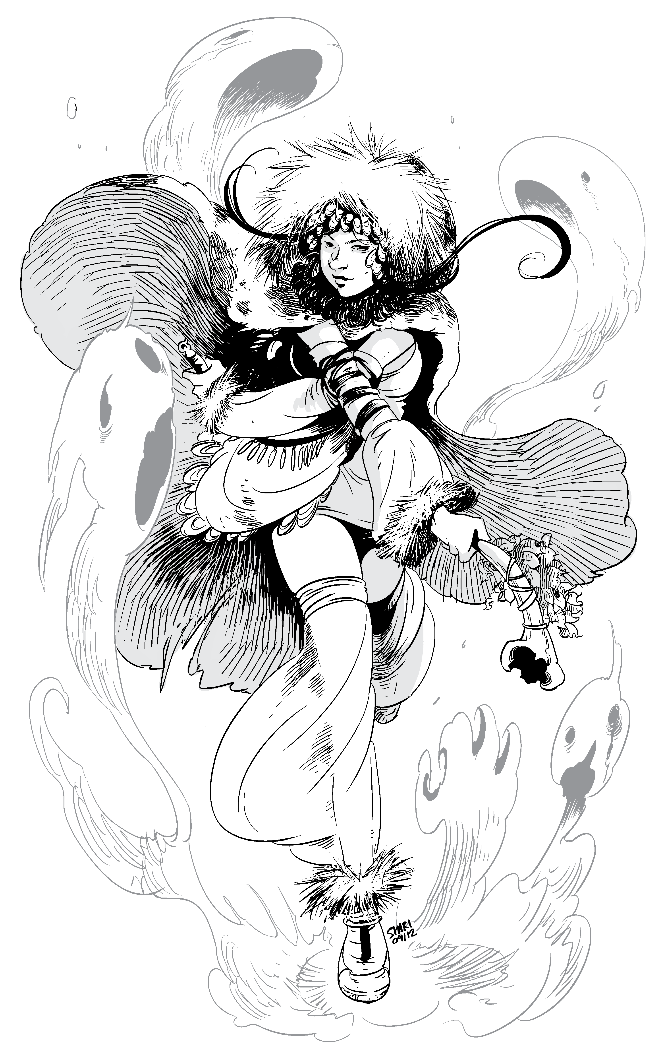
Replaces: Automated Targeting Systems
When you wound a living, organic enemy, your next attack against the same foe deals +1d8 damage.
Jet Propulsion
You can fly at any speed.
Kaiju Fighter
When you hack and slash a monster larger than you or defy its danger, take +1.
Precision Measurement
Requires: Mechanical Objectivity
When you examine an enemy’s structural integrity, ask the GM how many hit points they have.
Steel Hide
Replaces: Iron Hide
You gain +2 armor.
Superior Warrior
When you hack and slash, on a 12+ you deal your damage, avoid their attack, and impress, dismay, or frighten your enemy.
Transformer
Requires: Change of Face
When you transform your body to copy a creature, machine, or object that you have observed closely, roll +DEX. ✴ On a 10+, hold three. ✴ On a 7–9, hold two. ✴ On a miss, hold one anyway.
Spend your hold to pass yourself off as the thing you are copying when scrutinized or to use one of your robotic abilities without transforming back to your normal form.

The Necromancer
A class by Giovanni Lanza
There are certain assumptions people make about death. Death is final. You either go up with the angels or down with the devils. Once the body dies the magic is gone. What else is the soul used for?
Whether in a respected mage college or in your hut far removed from society, you have uncovered the secrets of binding a soul to your will. This connection to the spirit world has granted you abilities far beyond most people’s imaginations.
So what do you say? Knock ‘em dead.
Names

Dwarf
Emet, Momor, Oyama, Sekhmet, Nero, Cega, Doriru, Iesi, Berod, Airi, Rimna, Lahi

Human
Leoric, Nihlath, Myrkul, Azoth, Imhotep, Mordecai, Nija, Nihasa, Prosperine, Zente
Look
Choose one for each:
Haunted Eyes, Dead Eyes, or Inky Black Eyes
Wild Hair, Bald, or Styled Hair
Tattered Robes, Fine Robes, or Traveling Clothes
Bony Body, Wasted Body, or Mummified Body
Stats
Your maximum HP is 6+Constitution.
Your base damage is d6.
Starting Moves
Choose a race and gain the corresponding move:
Dwarf
You can cast a version of the cleric’s divination spell by spending 1 Soul, though you can only see past visions of dead people.
Human
As long as you have at least 1 Soul, you gain +1 to parley.

You start with these moves:
Soulthief
When you perform last rites over a sentient humanoid and take a fetish from the body, roll +INT.
✴ On a 10+, you gain 1 Soul. ✴ On a 7–9, you gain 1 Soul, but the spirit of the deceased wants something in return. Choose one:
- You take 1d4 damage
- The spirit of the deceased curses you; take −1 forward to your next action
- You have to perform a service for the spirit
You can only have as many Souls as your level+1, and they stay bound until used. You can spend 1 Soul to create the following effects:
- Contact spirits, as the wizard spell
- Put on the Mantle of Death, creating an effect equivalent to the cleric spell cause fear cast on a target of your choice with you as the frightening object
- Manifest a Ghost Light, as the wizard cantrip light
When you make a roll using +Soul instead of a stat, you cannot add more than your INT to the roll no matter how many souls you have collected.
A fetish has 1 weight.
Touch of the Grave
When you hack and slash, you deal additional damage equal to the number of Souls you have.
Vampiric Touch
When you touch someone and focus on their life energy, roll +INT. ✴ On a 10+, you deal your damage to the target and heal yourself of that much damage. ✴ On a 7–9, choose one:
- You take what you can get, dealing and healing half damage
- You spend 1 Soul
- You put yourself in a bad spot
Forbidden Lore
When you spout lore about spirits or the lands beyond the Black Gate, take +1 forward.
Alignment
Choose an alignment:
Good
Carry out a spirit’s last request.
Neutral
Uncover a dead secret.
Evil
Cause terror in living creatures.

Gear
Your Load is 7+STR. You start with dungeon rations (5 uses, 1 weight). Choose your defenses:
- Leather armor (1 armor, 1 weight)
- Bag of books (5 uses, 2 weight) and 3 healing potions
Choose your weapon:
- Sacrificial dagger (hand, 1 weight)
- Scythe (close, two-handed, 1 weight)
Choose one:
- Bandages (3 uses)
- Candles and incense (+1 forward to soulthief, 3 uses, 1 weight)
Bonds
Fill in the name of one of your companions in at least one:
I helped one of __________’s ancestors be at peace.
I brought __________ back from Death’s Door.
__________’s beliefs about the afterlife are wrong. I shall try to show them the truth.
Advanced Moves
When you gain a level from 2–5, choose from these moves.
Bloodsucker
When you use vampiric touch, you deal d8 damage.
Deathwatch
When you focus on someone, you can tell how many hit points they have.
Ectoplasmic Defense
While you have at least one Soul, you have 2 armor.
Lifesense
When you concentrate, you can detect the life force of creatures nearby.
Multiclass Dabbler
Get one move from another class. Treat your level as one lower for choosing the move.
Soul Magic
Choose from either the cleric or wizard spell lists. You can cast a spell from that list as if you were a wizard or cleric of your class level −1 by spending a soul.
Spirit Lore
When you first encounter an important creature, location, or item (your call) that pertains to spirits or the afterlife, you can ask the GM any one question about it; the GM will answer truthfully.
When you gain a level from 6–10, choose from these moves or the level 2–5 moves.
Black Arrows
You can volley with +Soul instead of +DEX, and your weapon gains the ignore armor tag.
Bloodsucking Fiend
Replaces: Bloodsucker
When you use vampiric touch, you deal d10 damage.
Ectoplasmic Armor
Replaces: Ectoplasmic Defense
While you have at least one Soul, you have 4 armor.
Grim Reaper
When you hack and slash, you roll +Soul instead of +STR, and your weapon gains the ignore armor tag.
Multiclass Initiate
Get one move from another class. Treat your level as one lower for choosing the move.
Student of Magic
Requires: Soul Magic
Get one move from the cleric or wizard advanced move list.
Unfettered Souls
You no longer need to tie a Soul to a fetish when using soulthief.
Vitality Transfer
You can use your vampiric touch to heal someone else. You must touch both creatures in order to do this.

The Warrior
A class by John Ryan
Barbarian. Savage. Berserker. Monster. Beast.
You’ve been called all these names, and more, by these people who hold their pretty courts in their cities and hide behind their walls from the darkness, who proclaim themselves chosen by the gods, then stab each other in the back over a few handfuls of gold. And they call you a savage? They have sworn no oath they will not break, and have no honour they will not sell.
You know what is good in life. Blood and war, victory and honour. There is beauty in a clean kill, honour to be found in a good death.
Today is a good day to die.
Names

Dwarf
Gotrek, Katrin, Frey, Tordek, Korrim, Akrek

Elf
Cyrus, Varyia, Dessia, Daevys, Skyra, Rysind

Human
Kane, Alaric, Boudicca, Wu Shi, Anyanka, Morganna, Jamaal, Domina, Leonid
Look
Choose one for each:
Hardened Eyes, Mad Eyes, or Sharp Eyes
Long Flowing Hair, Mohawk, or Bald Head
Scarred Face, Tattooed Face, or Angular Face
Nearly Naked, Leathers, or Animal Hide
Stats
Your maximum HP is 10+Constitution.
Your base damage is d10.
Starting Moves
Choose a race and gain the corresponding move:
Dwarf
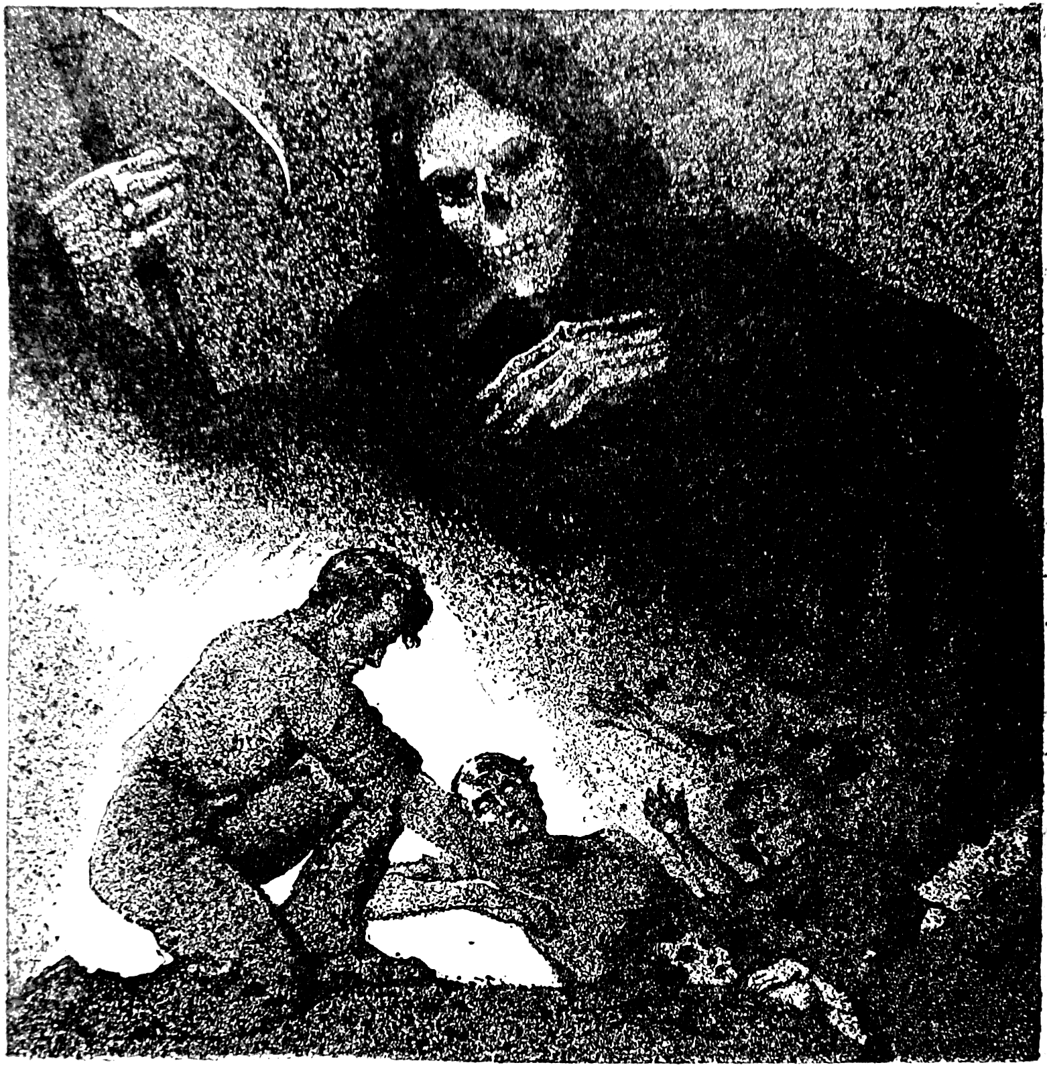
Choose one specific type of foe: dragons, giants, goblin-kin, or demons. When you battle against that foe, deal +1d4 damage. Add “Never let a _______ live” to your code.
Elf
As long as you hold fury, you can Hack and Slash using DEX instead of STR, and you can spend 1 fury to add your DEX to your damage.
Human
As an outsider from beyond the so-called “civilized” lands, you take +1 to parley with those who are shunned by “civilized” society.
You start with these moves:
Warrior’s Code
Choose 2, 3, or 4 options for your code:
- Always fight hand-to-hand
- Never lie or cheat
- Always offer enemies mercy
- Never let a slight go unchallenged
- Never wear armour
- Always protect the weak
- Never let an enemy walk away from a fight unscarred
As long as you hold true to your code, you can still hold fury. If you break your code, you cannot hold fury until you somehow redeem yourself through a quest or sacrifice.
Heat of Battle
When you charge into battle heedless of the risks to yourself, hold 2. This is your fury. You can hold a maximum amount of fury equal to the number of restrictions in your warrior’s code. Lose all your fury held when the battle is over, or you retreat.
When you make a hand-to-hand attack, spend a fury to:
- Add forceful, stunning or 2 piercing to your attack
- Add your STR to your damage
- Deal damage to another target within your reach
You Don’t Want To Make Me Angry
Whenever you take damage, hold 1 fury.
Bend Bars, Lift Gates
When you use pure strength to destroy an inanimate obstacle, roll +STR. On a 10+, choose 3. On a 7–9 choose 2:
- It doesn’t take a very long time
- Nothing of value is damaged
- It doesn’t make an inordinate amount of noise
- You can fix the thing again without a lot of effort
Alignment
Choose an alignment:
Good
Stand up for the weak in the face of insurmountable odds.
Chaotic
Break a law of the “civilized” world.
Evil
Punish the dishonourable at some cost to yourself.
Gear
Your Load is 12+STR. You carry dungeon rations (5 uses, 1 weight) and a minor treasure or heirloom worth at least 12 coins. Choose one serious weapon:
- Mighty axe (+1 damage, close, 2 weight)
- Hefty warhammer (forceful, close, 3 weight)
- Bronze spear (2 piercing, reach, 2 weight)
Choose your defense:
- Leather armour (1 armour, 1 weight)
- Sharp dagger (+1 damage, hand, 0 weight)
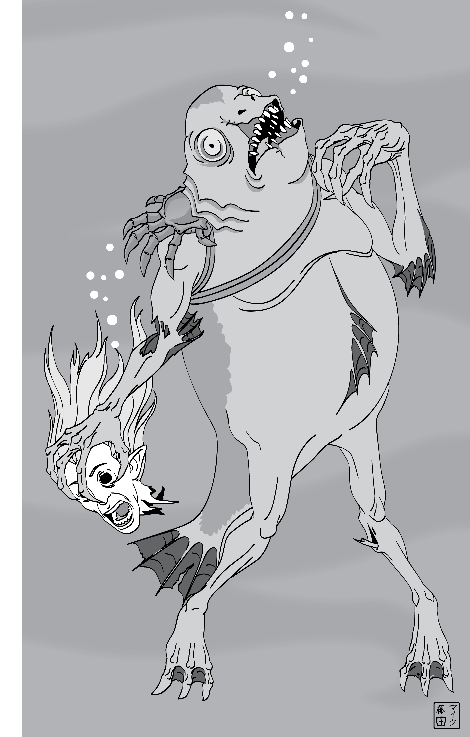
Bonds
Fill in the name of one of your companions in at least one:
_______________ owes me their life, whether they admit it or not.
I have sworn to protect _______________.
I worry about the ability of _______________ to survive in the dungeon.
_______________ is soft, but I will make them hard like me.
Advanced Moves
When you gain a level from 2–5, choose from these moves.
Bloodthirst
When you slay a foe, hold +1 fury.
Come And Get It
When you call out a foe in single combat, roll +CHA. ✴ On a 10+, it’s on: no-one else will attack you, and your chosen foe will only attack you. ✴ On a 7–9, choose 1:
- Your chosen foe honours the duel. His buddies? Not so much
- Nobody else will come at you, but your chosen foe has no compunctions about slaying anyone who stands between you and him
Red Visions
When you discern realities in battle, roll with fury instead of WIS.
Too Angry To Die
If you drop to zero HP, you don’t have to take your last breath until you spend all your fury or the battle ends.
By Grabthar’s Hammer
When you see an ally defeated, take +1 ongoing, forever, against whichever foe took them down.
Hear My Roar!
When you charge into battle screaming at the top of your voice, hold 3 fury instead of 2.

To Me, My Brothers!
When you attempt to rally warriors to your banner, roll +CHA. On a hit, you rally a band of warriors who will fight for you for one battle. On a 10+, choose 3. On a 7–9, choose 2.
- The war-band is as large as you could hope for
- The war-band you select will follow you into the jaws of hell itself
- The war-band is well-equipped
- The war-band is made up of veteran warriors
- The war-band will not expect a great reward at the end of the battle
Wrestlemania
When you grapple with a foe, roll +STR. ✴ On a hit, you successfully pin them in place, unable to act. ✴ On a 10+, hold 3. ✴ On a 7–9, hold 1. Spend your hold one-for-one to:
- Move them a short distance, keeping them pinned.
- Expose them to an ally’s attack.
- Deal damage to them.
- Hurl them into the air.
When your hold is spent, they are no longer pinned.
Mystic Warrior
Get one move from the druid class.
Excalibur
Choose a weapon you have used to slay a legendary and terrible foe. When you brandish that weapon, take +1 to CHA moves.
I Will Be Your Shield
When you defend, you can spend fury as if it were hold to choose options from the defend list.
When you gain a level from 6–10, choose from these moves or the level 2–5 moves.
The Rock
Requires: Wrestlemania
When you grapple with a foe, on a hit you can spend your fury as hold.
The Hard Place
When you defend, add your fury to your armor.
Spirit Warrior
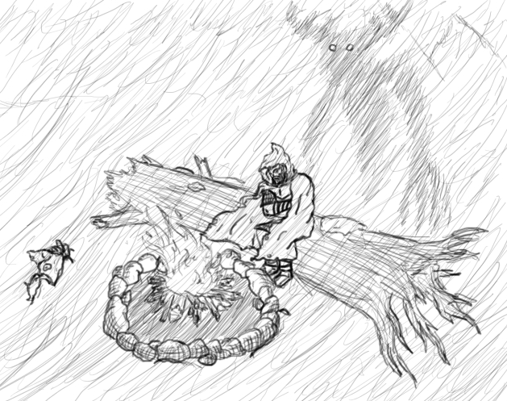
Requires: Mystic Warrior
Choose another move from the druid class list.
Unstoppable
When you roll with STR or CON, you can spend 1 fury to add +1 to your roll, retroactively.
Heave & Cleave
Add the following option to heat of battle: “Deal damage to every foe within your reach”.

Great Khan
Requires: To Me, My Brothers!
When you gather warriors to your banner, you get to choose an extra option on a hit. Add the following options to the list:
- The war-band will bring mystic powers or ancient artifacts to bear on your foes
- The war-band will follow you as long as you continue to bring them victories
Bone-Breaker
Add the following option to heat of battle: “Break their bones”.
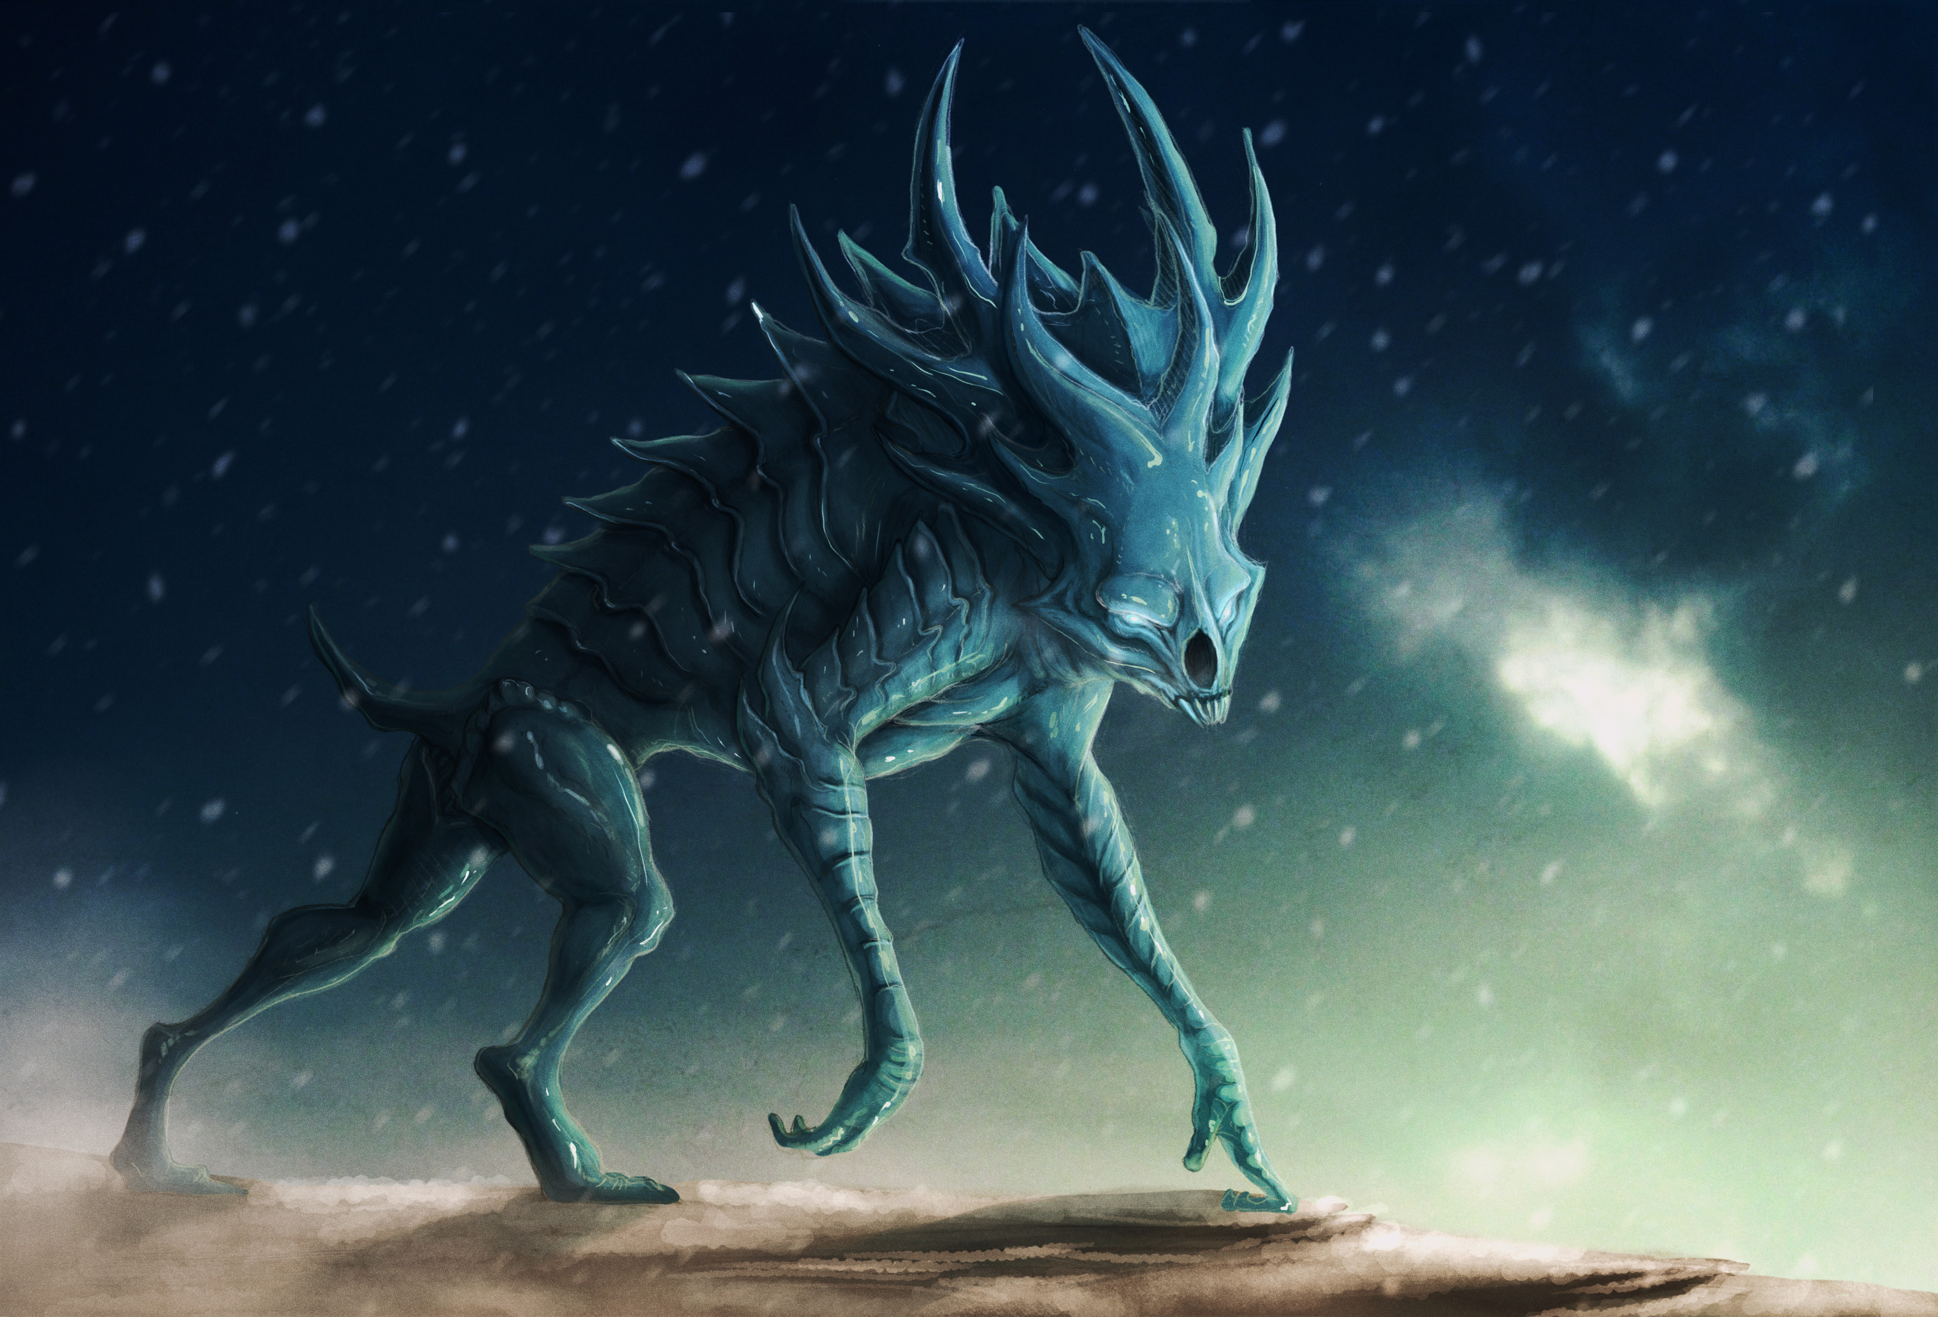
A Coward’s Tools
When you suffer damage from ranged weapons, take half damage after armor.
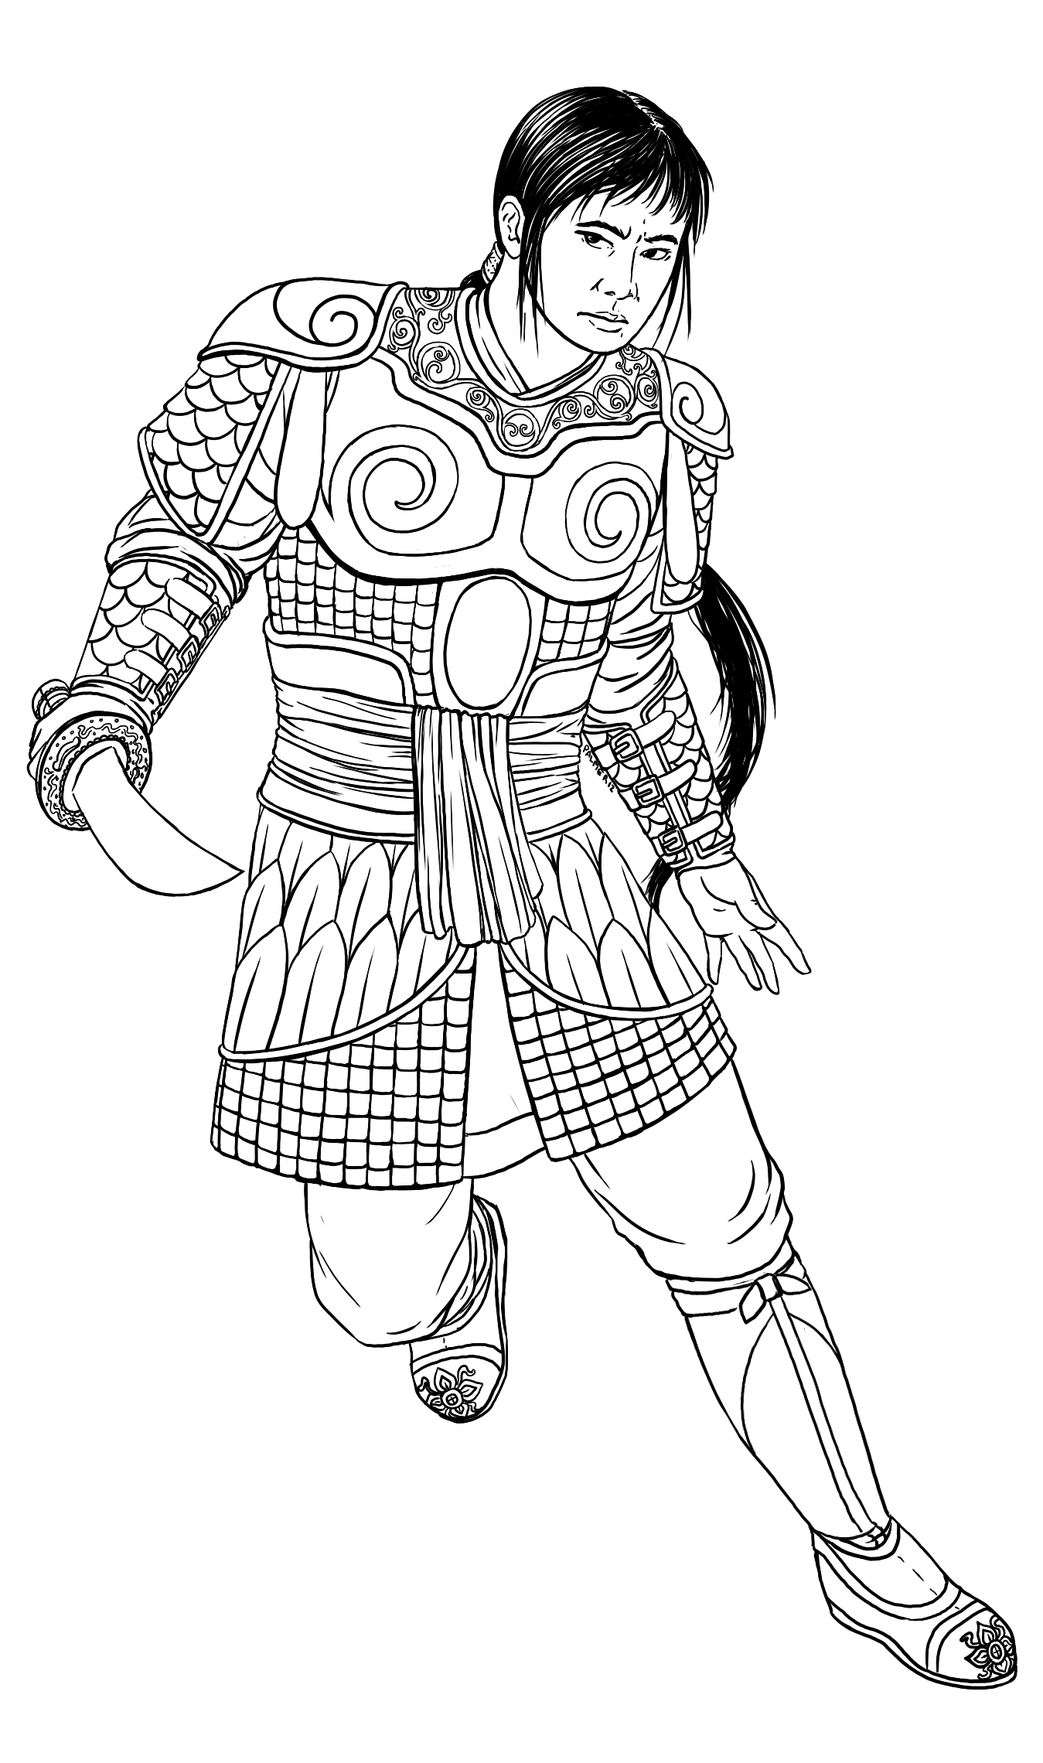
Destroyer
When you spend fury on an attack, it ignores armor.
I’m Always Angry
You can always hold up to 3 fury, even if you break your warrior’s code.

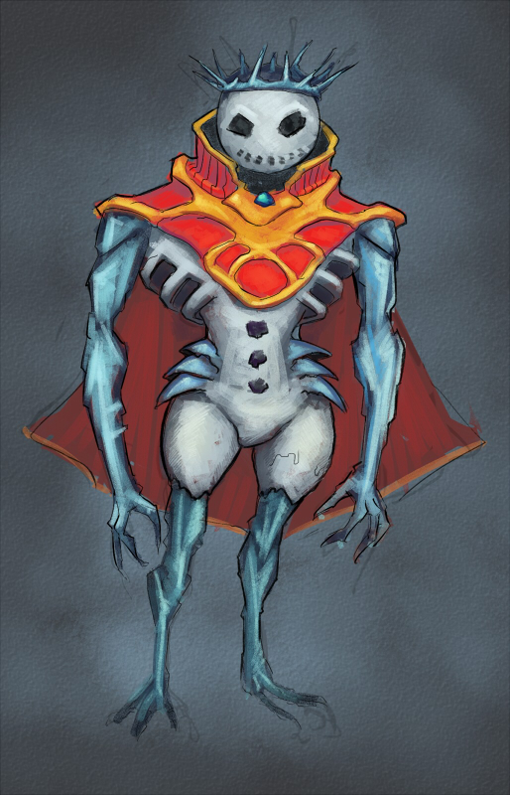
The Miscellany
Glamour was created by Scott Velez

Glamour
2 uses, 20 coins, 1 weight
A potent drug made from crystallized raw magic. Ground up and further refined by any number of seedy fellows, Glamour has recently become popular with the wealthy, the eccentric, and the wizarding community. Each dose comes in a small glass vial. Don’t mind the odd glow, that just means it’s fresh. Now do you want it, or don’t you?
When you ingest Glamour, roll +CON. ✴ On a 10+, pick 2 from below. ✴ On a 7–9, pick 1. Either way, you experience vivid hallucinations and the high lasts about an hour.
- Well, that was … pretty damn good, actually. In fact, a person could really develop a problem with this Glamour stuff. But not me. You avoid addiction. This time
- Glamour expands your senses out beyond the veil. So what if no one else sees? Wait, what do you mean spells can’t talk? Hold 1. For the next hour, you can spend your hold to parley with an ongoing magical effect you encounter and convince it to end (magical items so affected will become magical again after some time), change, or reverse itself. You are considered to have leverage
- The vivid hallucinations you’re experiencing provide a glimpse of things to come. Hold 2. Spend your hold to take +1 forward to defy danger or discern realities

The Compendium of Classes
The Bone Knight
A compendium class by Giovanni Lanza
When you collect several skeletons and form a suit of armor from them, then perform the Ritual of the Deathless to bind it to your flesh, you may take this move the next time you level.
Exoskeleton
You form a suit of armor made of bones that fuses to your flesh. This has 3 armor and 4 weight. In addition, undead treat you as one of their own.
If you have the move exoskeleton, these count as class moves for you; you can choose from them when you level up.
Skeletal Servitor
You animate a skeleton to serve you. Treat it as a hireling with one of the following skills:
- Burglar 3
- Protector 3
- Warrior 3
Your servitor has no Loyalty or Cost. If it is ever destroyed, you can reanimate it in a couple of days.
Skeletal Entourage
Requires: Skeletal Servitor
You animate another skeleton servitor. Choose a different skill for this hireling.
On a Pale Horse
When you summon skeletal steeds for you and your companions and you ride them like devils through the wild, treat it as rolling 10+ on the trailblazer roll to Undertake a Perilous Journey.
Death Never Eats, Never Sleeps
Your link to the undead grants you vitality. When a move tells you to mark off a ration, ignore it. In addition, you are immune to sleep and can gain the benefits of making camp with a few hours spent mending your exoskeleton.
The Flatliner
A compendium class by Marshall Miller
When you intentionally draw your last breath, you may take this move the next time you level, if you survive.
Face of Death
Write an additional bond with Death; this bond can be resolved as usual if you so desire. Hereafter, when you write a new bond, you may write it with Death. When you take your last breath you roll +bond with Death.
After you have seen the face of Death, these count as class moves for you; you can choose from them when you level up.
Devil’s Advocate
When you hold a dying person in your arms, you too see what lies beyond the Black Gates of Death’s Kingdom and you may use your bond with them or with Death to aid or interfere as they take their last breath.
At the Crossroads
When you draw your last breath and roll a 10+, it’s not your time. Before you stabilize, you may offer Death a bargain on your own terms. Use your mortal coil as leverage when you parley.
Dead Eyes
When you discern realities, you can see as Death sees all things. In addition to the normal questions, you may also ask:
- Whose time draws nigh?
- Whose time has not yet come?

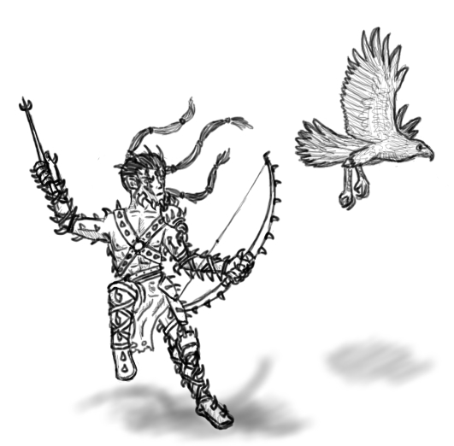
The Psychopomp
A compendium class by Parker D Hicks
When someone you love dies and you accept Death’s decisions as final, you may take this move the next time you level.
The End is Important in All Things
Death’s word is law. You no longer have access to the last breath special move.
When you die, your weapons and armor become relics of great power. Roll +nothing. ✴ On a 10+, all 3. ✴ On a 7–9, choose 2. ✴ On a miss, choose 1, but a great undead power will mark the relics for perversion and destruction (and the GM makes a move as normal).
- The relic glows when undead are far or closer.
- The relic burns undead flesh (grants +1 armor or +1 damage against undead)
- The relic seeks unerringly to end undeath (grants +1 ongoing against undead)
If you have the move the end is important in all things, these count as class moves for you; you can choose from them when you level up.
Last Rites
When you have a few peaceful moments with a corpse, you can ensure it will never rise again.
Music of the Dead
When you strike the chimes to banish lost souls, roll +CHA. ✴ On a 10+, any undead in the area take 1d8 damage and are stunned as Death reaches back for them. ✴ On a 7–9, the chimes pull all who can hear them: undead take 1d6 damage and the living are shaken as a vision of Death (perhaps theirs?) flashes before their eyes.
Séance
Once per day, you may shut your eyes, approach the Gate, and call a spirit to its other side. If you have time and focus, you may call anyone you knew in life. If you are rushed or distracted (by the clash of swords, perhaps), you may only call on those who died near your present location. Any spirit you call will speak with you honestly, but you may only speak 27 syllables in the common tongue to it.
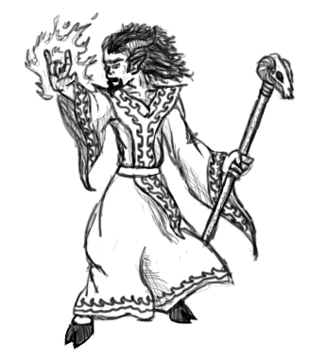
While you are communing, your body is empty and vulnerable. If you suffer any harm while communing, your séance is broken and you may not attempt another today.

Monsters
The dracolich was created by Jeremy Friesan and originally appeared in Take on Dragons.
The ice mummer was also created by Jeremy Friesan
The wendigo spirit and the wendigo beast were created by Jeremy Strandberg
Drowned Solitary, Stealthy
Slam (d10+2 damage) 20 HP 1 Armor
Close, Forceful
Special Qualities: Amphibious, Drowning aura
The drowned lost their lives in the watery deep. The evidence of their gasping death always saturates their clothing and flesh, and fills the air around them.
Many drowned came to their current circumstances when their ships went down at sea with all hands. Others, more ancient, first arose when their island homes sank beneath the waves ages ago, drowning all. Instinct: To drag down to the depths
- Drown someone, underwater or not
- Suddenly attack from water
- Bring someone underwater

Dracolich Solitary, Cautious, Hoarder, Intelligent, Huge, Magical, Undead, Terrifying
Bite (b[2d10]+4 damage, 4 piercing) 20 HP 5 Armor
Reach, Messy
Special Qualities: Creature of death
Extending a dragon’s already long life beyond the threshold of death, the dracolich is the most miserly of creatures. Consumed by greed yet patient beyond comprehension, the dracolich is a dangerous cancer, laying plans that span decades and centuries. Instinct: To amass and sequester knowledge
- Breathe enervating shadows
- Command and control the ancient and forgotten
- Avoid destruction by reforming at its phylactery
Ice Mummer Group, Devious
Slam (d6 damage) 13 HP 1 Armor
Close
Special Qualities: Made of ice
The meticulously reconstituted frozen remains of a person ritually frozen then shattered into thousands of pieces, an ice mummer is the agent of a greater evil. Bound to its icy oxidized bronze mask, the voiceless ice mummer is a harbinger of its master’s incursion. Instinct: To obey its master
- Reveal the horror beneath the mask
- Disperse in a whirlwind of ice and snow
- Be its master’s eyes
Wendigo Spirit Solitary, Devious, Intelligent, Planar
Special Qualities: Insubstantial, Invisible
Hunger calls it forth, hunger in the long long nights and the never-ending cold. First you hear it as a whisper, dark thoughts you’d never think: "he’s not going to make it" and "why should both of us starve?" And it grows, grows to a howl, until your only thoughts are "a waste of good meat" and "stringy, sure, but he’ll cook up nice." And that first bite, I bet it’s all the spirit promises. But that first bite lets the spirit in, clothes it in your flesh, and then you’ll never be satiated again. Instinct: To goad into cannibalism
- Despoil wholesome food
- Amplify want and hunger
- Whisper terrible thoughts from within

Wendigo Beast Solitary, Terrifying, Stealthy
Rend and bite (d10+2 damage) 16 HP 1 Armor
Close, Forceful, Messy
Gaunt and terrible, with skin pulled back on its bones. Darting, once-human eyes set back deep in their sockets. Tattered and cracked lips spread thinly over too-white teeth, with breath like rotting meat. This is what one becomes when one gives in to the wendigo’s call, when one dines on the flesh of one’s fellows and lets the spirit in. A vessel for gluttony, growing ever larger and stronger as it feeds. Instinct: To gorge itself
- Unleash a horrid, bone-chilling howl
- Drag off a lone straggler
- Grow in strength, size, and hunger after feeding

Templates
An article by Alexander Davis
Frostborn
When something—near anything—dies out in the ice and snow, sometimes the spirits of deathly frost claim it for their own. It’s reborn, an icy thing half-dead half-alive, filled with cold hatred.
Frostborn is a template that can be applied to any monster that once lived. It gains the Magical and Construct tags, becomes Solitary (if it wasn’t already), gains +4 HP, and the move “Freeze them with a glance or a touch”.
Ravenous
Out here, in the winterfrost, food is scarce. Some go mad, feasting on their brethren and attacking any who come near.
Ravenous is a template that can be applied to any intelligent, living monster. It loses any moves, qualities, or other traits related to groups or community and becomes Solitary (if it wasn’t already). It also loses the Intelligent tag. It gains the Terrifying tag, −2 HP, +2 armor, +2 damage, and the move “Tear off some flesh”.

Chillspeaker
Some of the goblin tribes who live in the eternal winter have learned a new and mighty magic, one that trades the warmth of souls and blood for mastery over the deathfrost. From them, it has spread to the ogres, the orcs, even the trolls.
Chillspeaker is a template that can be applied to any intelligent monster. It gains the Magical tag and the moves “Sacrifice someone to fuel unholy powers”, “Animate the snow and ice around them”, and “Attack with magic of ice and snow”.

Companions
An article by At the Table Games, <http://atthetablegames.com>
Along your quests there will be those who decide to follow you of their own volition. These Companions are not a huge help because, let’s face it, they are not hero material—but they do have their uses. They are the GM’s to control and are the PCs’ to abuse at their peril. The GM is welcome to put them in danger as a hard move and potentially even kill them if that move is ignored, but they are not cannon fodder. If you are a GM add, "Make the Companions seem like real people" to your principals and add "Have a Companion speak up in opposition", "Have a Companion strike out on a quest of their own", and "Put a Companion in a tough position" to your list of hard moves.
Companions are typically a reward for dealing with fronts. They may be NPCs with a stake in the outcome or a hireling that the party treated extremely well. In either case it it up to the GM if the group receives a Companion. Players may request a Companion but it is ultimately up to the GM.
A party can have a number of Companions equal to the number of players.
Each companion adds a bonus to the group: a spell, a move, a damage die, hit points, or armor. What the bonus is and how big a bonus it is is up to the GM.
Companion spells can be cast by any character that can cast.
Companion moves can be used by anyone in the group.
One Companion damage die can be added to any one attack per encounter.
All of the Companion’s hit points are added together and players can choose if damage is dealt to them or the Companions. If the Companion’s HP pool empties a Companion dies. Companions heal like characters only as a group.
Companion armor is combined and added to each character’s armor, including the Companions themselves if they are dealt damage.
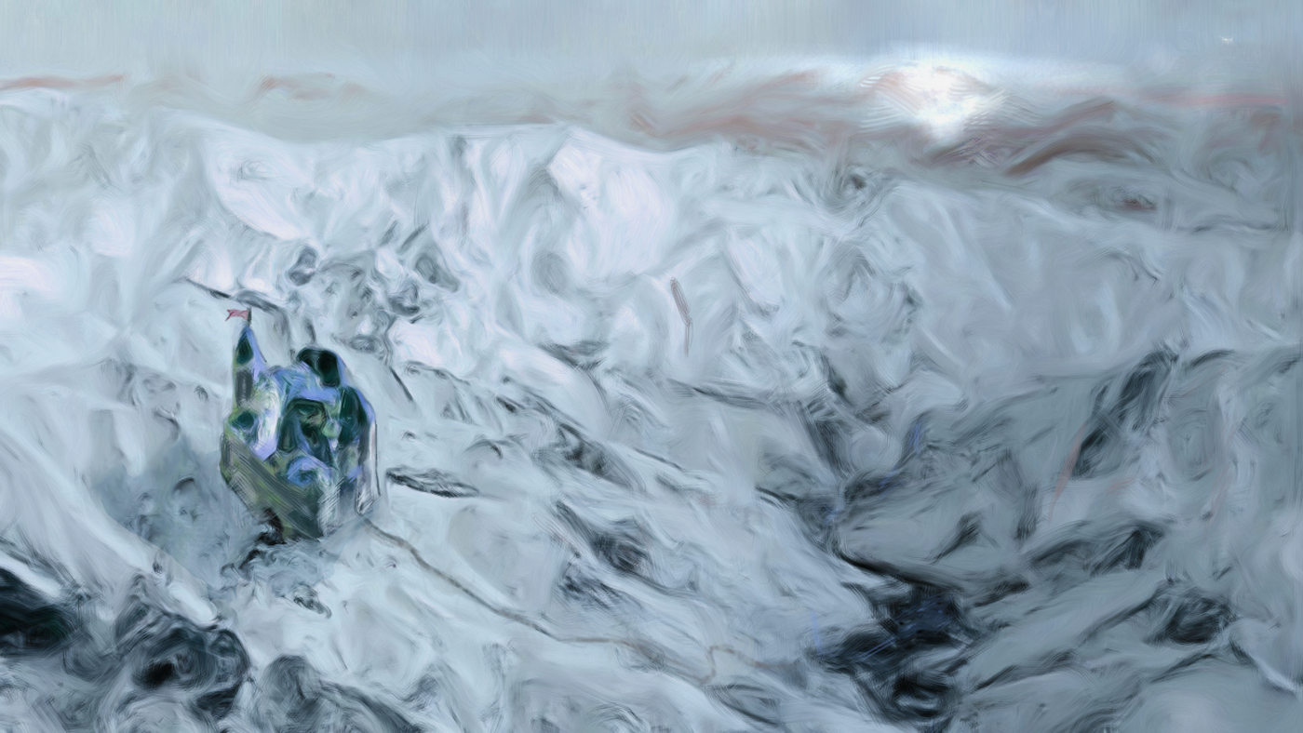

Gnomes
An article by Kingston Cassidy
Gnomish Guerrilla Group, Stealthy, Small, Cautious, Organized, Intelligent
Crossbow (d6+1 damage) 6 HP 2 Armor
Near, Reload
“Shadow is mother to the Gnome. Yes, in our blood runs the sap of the elven vale and the stone of the dwarven mine, but what of it? It was the shadow we hid in when, all too often, our kin scorned us. It was in shadow we found one another. It was in shadow we hid when the nations of Elf and Dwarf alike fell to the enemy, and it was from the shadow we struck and took this land for our own.
“Come, young one. Meet your mother.” Instinct: To ambush
- Attack from a concealed, camouflaged position
- Spring a trap
- Regroup
Gnomish Illusionist Solitary, Stealthy, Small, Organized, Intelligent, Magical
Nightmare Bolt (d10 damage, ignores armor) 12 HP 1 Armor
Near, Far
Illusionists are often dismissed by the magicians of other races as creating no real magic, just phantasms of smoke and echo. The illusionists know better. They say that the occult formulas of man’s wizardry are a lie. The secret symphony of the elven arcanist, too. They say all magic is a lie, told to the universe, so convincing that it fools light, hoodwinks time, and deceives death itself. All magic is illusion, and so illusion is the highest magic of all. Instinct: To fool the senses
- Create an image of something that is not real
- Hide something using magic
- To seek the truth behind the veil of illusion
A Gnomish Village

Twelvemaples Poor, Steady
Safe, Gnomish, Resource (syrup), Oath (the elves of Cal Seeate), Enmity (Duke Arrithorn)
Deep in the forest, hidden underground among the root systems of the twelve ancient maple trees that give the burrow (as gnomes call their villages) its name, the gnomes of Twelvemaples harvest sap and refine it into the sweetest syrup and the most intoxicating liquor. Long kept safe by its isolation and by cunning architecture that disguises the burrow as part of the forest itself, the village has recently drawn the attention of the Duke of Arrithorn, who has claimed the village and demanded tribute. But can the Duke and his men rule a village that they cannot find?

Gnomish Characters
Bard
Add the following effect to the list of things you can do with arcane art:
- Perform minor acts of illusion, as the wizard spell prestidigitation
Druid
In addition to any other attunements, the Depths of the Earth is always considered your land
Fighter
Gnomish warriors are masters of camouflage. When you have time and have the right materials, conceal yourself and take +1 forward.
Ranger
Your people have domesticated those beasts who make their lives underground. You can take a dog-sized mole or badger as an animal companion, which has burrow as a free training.
Wizard
Take +1 ongoing to any attempt to cast an illusion spell.

Extraplanar Races
An article by David Guyll

Bladeling Characters
Fighter
When you attack with a melee weapon with a range of close or hand, deal +2 damage.
Ranger
Your supernatural connection to your animal companion makes it tougher, increasing its armor by 1.
Thief
When you take damage from a character’s attack with a range of close or hand, deal 1d4 damage to that character.
Bladeling Advanced Moves
Iron Skin
You can apply your armor to attacks with the ignore armor tag that deal cold or fire damage.
Metalshaping
You can grow spikes from your hands. They can be used to create weapons with a range of Hand, Close, or Near.
Razor Storm
Once per battle you can unleash a burst of metallic shards. It affects everyone nearby, and you deal your damage twice.

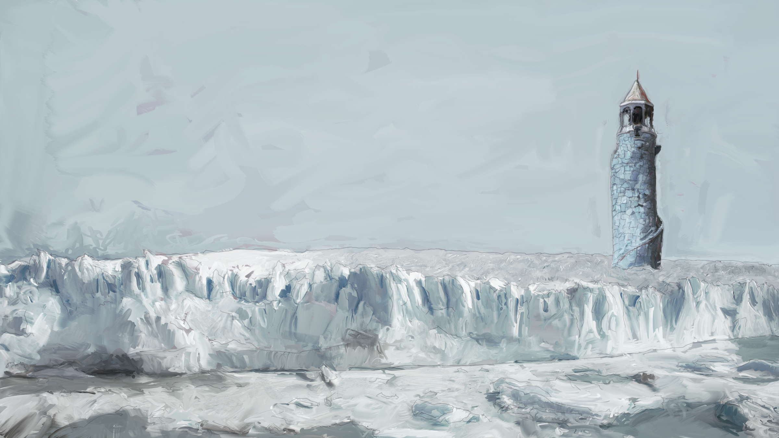

Stormsoul Genasi Characters
Fighter
Attacks with your signature weapon gain the ignore armor tag.
Thief
When you hack and slash, with a result of 10+ you momentarily stun your victim. The next action made in response to it gains +1 forward.
Wizard
When you attack with your hands, you may use INT to hack and slash. If you hit, deal +1 damage

Tiefling Characters
Bard
When you spout lore about demons and devils, take +1 forward.
Fighter
When an enemy deals damage to you, your next attack against them deals +1d4 damage.
Thief
When you are in a shadowy environment, take +1 ongoing to defy danger
Wizard
When you cast a spell that inflicts fire damage, on a 7–9 you deal +1d4 damage, and on a 10+ you deal +1d6.

The Rythbjörn
By Matthew Gagan
Illustrations by Nate Marcel
There is more to the Nordemark of Dungeon World than the twisted draugr, its giants and its trolls. There is also its native Rythbjörn, the animistic nomads that came before the frontier people that now settle the northern lands.
With mysterious but resolute purpose, the Rythbjörn patrol their territories in the Trullspar Hills of the Nordemark. In obscuring snows they watch those who encroach upon their circuit and their presence will not be known unless they wish it. Alone or in pairs they ride the great snjórbjörn they have bonded to themselves with sacred and secret rite.
This article presents a people of the Nordemark and their pledged mounts. It may be that little is known about the Rythbjörn by the players at the outset of your Dungeon World game beyond the illustrations that accompany this piece and the words written above. Some additional details are offered below but you should treat them as you would those from a narrator you know to be unreliable. The rest of what is certain will be determined by the answers given by the players in response to the questions you ask and by your own invention.

Questions
Here are questions you might ask characters in the Nordemark about the Rythbjörn. These are necessarily leading because whatever else is true, these people were here from long before. Well before you stumbled along.
Though you know little of them, you know one among the Rythbjörn and they call you friend. Is it Ketil or Sædís and why does the current leader of the Rythbjörn have misgivings about them? (Ranger/Druid/Barbarian)
While it is certain they do not share your faith, you know the Rythbjörn have no fondness for the unliving and some believe they are spoken of in the texts of your deity. What do those texts say, and what do you? (Cleric/Paladin)
Those who've traveled with them and returned to civilized lands say the Rythbjörn speak in hushed tones of an artifact they know as “The Heart of Winter”. What have you heard about this wondrous item? (Bard/Wizard)
It is said it is a challenge to surprise or to gain the upper hand on the Rythbjörn in combat. What have you heard about why this is so? (Fighter/Thief)

The Rythbjörn and Snjórbjörn as Monsters
“Gods help you if you're in the Trullspars and the Rythbjörn decide your purpose isn't right. Worst is they have an uncanny sense of coming along when you're already not at your best. Course, that's almost always if you're tramping about in the Nordemark. At least they don't come at night. Some kind of honor thing.”

Rythbjörn Group, Intelligent, Organized
Spear (d8 damage) 6 HP 1 Armor
Close, Reach
“Bear Riders we call them. To be sure that's the first thing you notice and most don't know much else. No ordinary bears though judging by their size. They talk to them with whispers like a boreal wind and the bears seem to understand too. Their faces are hidden and they wear those salt-bleached wolf furs and leathers. Evil? No, I wouldn't say so, but they've got this thing about paths and whether you're meant to travel them. They decide you're on the wrong one in their territory and you've got trouble. May decide to end your wanderlust with a spear to the chest and then just as quickly end any hostilities if you can prove your worth. Some say its up to the bear. You've slain trullkin, giants or undead recently then maybe they'll let you be. Or maybe the bear decides you don't smell right…” Instinct: To understand outlanders.
Names: Bjark, Jónu, Njáli, Rún
- Ambush and bloody any trespassers
- Ask a cryptic question
- Vanish into the snow
Snjórbjörn Group, Large, Organized
Claws (d8+3 damage) 10 HP 1 Armor
Close, Reach, Forceful
Special Qualities: Camouflage
“A ‘bear’ is not a fit word for any creature three time bigger and twice as smart than any bear I've seen in more southern climes, but that's what they look like. Their fur is a dirty white and they blend into the Trullspar snowbanks in a manner that isn't natural. They're quiet too. If you hear one growl it's probably too late for you unless they've decided you've got something in you that merits staying in one piece. Got no fear like a regular bear neither. If they break from the fray it's because they have somewhere else to be or their rider told them to. There's some kind of link between the snjórbjörn and their riders. It must be something special. How else would such a proud creature allow itself to be harnessed?” Instinct: To serve their bond.
Names: Blindside, Finder, Greyclaw, Wander
- Pin a foe beneath its bulk
- Scatter its enemies like twigs
- Judge someone's worthiness

Traveling the Trullspars
“Ancient crypts … trullkin … treacherous weather … The Trullspars are hostile territory
and a golden opportunity … for hard luck.”
Here are some moves a GM might make in the perilous uplands the Rythbjörn have made their home.
- A passel of white hares equal to the number of characters in the party hang from a small rowan tree, their necks broken and their eyes put out. They are still warm but no tracks can be found nearby. An offering or a warning? Perhaps both.
- A fierce snowstorm sets in. Without precautions the party risks the danger of being separated from one another. This is the most likely time for the group to encounter the Rythbjörn for the first time.
- The parley is going poorly and the characters sense the Rythbjörn will attack them unless they offer something precious to them as an act of respect. Coins will not do.
- When you are judged by a snjórbjörn, roll +WIS. ✴ On a 10+, there is something you seek which the snjórbjörn finds worthy. What is it? ✴ On a 7-9, the snjórbjörn is intrigued by you but you sense must do some substantial service for the Rythbjörn before you will be considered welcome in their lands.

Rythbjörn Lore
The current leader of the Rythbjörn is Fjóla, known as “Bonebreaker” (interesting).
Fjóla has directed her people to find the remains of her great-grandfather, Grímur, who was a scourge of the undead. Ghouls have delivered his bones to their master Hákonar for dark purpose and his ghost haunts her to deliver justice (interesting and useful).
The Rythbjörn choose valleys to ambush trespassers in their lands. These valleys are strangely quiet and still. The wind does not sweep them as it does other valleys (interesting).
If an ambush is going poorly for the Rythbjörn, that is the most dangerous time for their foes. Almost as though commanded, an avalanche of snow will soon fall from the valley slopes nearby, burying their foes and allowing them to escape into the drifts (interesting and useful).

Snjórbjörn as Hirelings
“Sometimes a snjórbjörn will decide your purposes and its are of a kind for a time. You won't know why unless you're one of those spirit-tongued druid-types of the north or maybe a ranger.”
Costs: Uncovered Knowledge
Loyalty: 0
Skills: Protector 2, Warrior 3

Friend to the Rythbjörn
When you gain a level from 6–10 and either a snjórbjörn or one of the Rythbjörn calls you friend you may choose this move:
Snowborn
You are Bearfriend and a Child of the North. Gain both the ranger's camouflage move as long as you are in the Towering Mountains or the Frozen North and the druid’s eyes of the tiger move with snjórbjörn. You and those you travel with are welcome among the Rythbjörn and you often have the opportunity to gain a snjórbjörn as a hireling with a starting Loyalty of 1.

Tower of Dosdaemon
An adventure by Bill White
As the adventure begins, the PCs find themselves caught in the wild on the outskirts of the Barony of Lanholm—to the north of Lake Silverweir, close to the Fangs of Ice that descend from the Great Northern Mountains—during an unseasonal snow storm. They come upon (or have been accompanying) a dwarven merchant named Rurik who is leading a small caravan of wagons trying to weather the storm. Begin the game with their actions during the blizzard; the caravan master will hope to retain the services of the PCs in order to get his wagons through the snow to safety. The PCs may be caravan guards, or woodsmen surprised by the freakish weather. Maybe they have been dispatched by Baron Aldric of Lanholm to find his son Egaric, who went hunting with some friends and servants several days ago and is overdue. In any event, they have been caught out in the blizzard and must find shelter—perhaps at Lanholm Keep.
Adventure Front: Lamentations of the Ice-Spirits
Description and Cast
Aniamadan, a silver elf sorcerer, has used his magic to open a path in the glacial Fangs of Ice to the ice-surrounded vale where the ancient Tower of Dosdaemon stands, from where he intends to work a great magic that will enable him to conquer the Forest Strongholds, which territory his people ruled long ago, when it was called Valienalla. But the opening of the way to the Tower has unleashed three ice-spirits or jotyna. They were imprisoned long ago by the great silver elf king Dosdaemon, and now free are finally able to vent their vengeful grief at the long-ago death of their icy Queen by starting a dreadful blizzard that immobilizes hapless travellers, including Rurik the dwarven merchant and his caravan, traveling with a load of wrought iron and steel tools. His route brings him westward from the dwarven fortress of Varjakhor in the Quickstone Mountains into the Forest Strongholds at the Barony of Lanholm, where he will trade for goods brought up the Mistfall River from the city of Anthol on the Foaming Sea or by road from the shores of Lake Silverweir, where the wood elves dwell.
- Rurik, dwarven merchant, and his hirelings, with wagons and trade goods
- Bialel, Cuerin, and Delisse, jotyna—airy ice spirits of the frozen North
Custom Moves
When you brave the freezing cold, roll +CON. ✴ On a 10+, you shrug off the effects of the cold.
✴ On a 7–9, the cold bothers you; take −1 forward. ✴ On a miss, you are chilled to the bone; take −1 ongoing until you shrug off the effects of the cold or take a break to warm up.
Dangers
Raging Blizzard
Type: Unnatural Storm
Impulse: To immobilize travelers.
- Blanket with ice and snow
- Chill with icy cold

Grim Portents
- Ice and cold interfere with routine tasks
- Huge snow drifts make the way forward to Lanholm Keep impassable
- An avalanche blocks the road back toward Belsarien, Gate of the East
- Frost bite appears on unprotected extremities: fingers, toes, noses, cheeks
- Rurik and his companions show signs of exhaustion and madness
Impending Doom: Destruction (Rurik dies in the snow, from exposure, starvation, or cannibalism)
Ice Spirits (“Jotyna”)
Type: Planar Forces
Impulse: To vent their wrathful grief
Description: They appear as unnatural vortices of snow, whirling in the air. Their voices carry on the wind like icy shrieks. They were freed from the Fangs of Ice by the undoing of ancient magic wrought by the sorcerer king Dosdaemon long ago, when he from his Tower—where they cannot go without being called thither—took the Frost Queen’s heart from her. Some time since they were bound in ice, the Frost Queen’s heart was shattered into pieces; they can sense its shards all over the land, though a big piece remains at the Tower and a large collection of fragments is assembled at the Grotto of Cascades, an ice cave in the hills north of the Mistfall River’s source. Without their Queen, they are bereft, and seek to assuage their grief by wreaking havoc. They are aware that a sorcerer of the line of Dosdaemon has opened a path to the Tower, and they are afraid of him. They can perhaps be appeased, if an adventurer can get them to listen.
Group, Magical
Cold Bite (d4 damage, ignores armor), Ice Needles (d6 damage) 5 HP
Hand, Reach
Special Qualities: Intangible, Vulnerable to fire, Vulnerable to magic
- Control weather with malicious intent
- Mourn the Frost Queen (and reveal information)
- Blast with frost
Grim Portents
- Frost rimes every surface
- Ice-blasted trees lie shattered upon the ground
- Half-heard icy voices shriek in a strange tongue on the wind from afar
- A lone woodsman or traveler is found pierced by ice
Impending Doom: Pestilence (unnatural frost blights this area, leaving it withered and barren)
Stakes
- Who will make it to safety out of the storm and its aftermath?
- Will the ice spirits remain free to wreak their vengeance upon the world of Man?

Adventure Front: The Shards in the Ice Cave
Description and Cast
After the time of Dosdaemon, a usurper betrayed the silver elf king Orcalaman, slew his family, and took the throne for himself. The usurper was called Quilthaneil—the “Bloody-Handed One”—by his foes. At the climax of a long and desperate civil war, Quilthaneil’s evil spirit was imprisoned in the diadem called the Frost Queen’s Heart, but this caused it to shatter into thousands of fragments which then rained down across the land in a shower of shards. It was then that the kingdom of Valienalla fell, as its capital city was crushed beneath the swiftly moving glaciers now called the Fangs of Ice. Aniamadan the sorcerer has managed to gather together some of these shards, which he will use to craft a powerful magical artifact that will enable him to command the ice-spirits to do his bidding. But he needs more if he wishes to be all-powerful, and he has learned that some of the shards fell into the headwaters that feed the Mistfall River, flowed downstream, and collected in a pool. There they exerted a powerful magic over the surrounding area, forming an ice cave called the Grotto of Cascades after its ice waterfalls. Aniamadan has dispatched his trusted lieutenant Turibar with a host of orcish warriors to find the Grotto of Cascades, gather as many shards there as he can, and quickly bring them to him at the Tower of Dosdaemon. During their search, they fall upon a hunting party led by young Egaric, son of the baron who rules this frontier region. They slay his men and take him prisoner, keeping him alive as slave labor once they find the Grotto and for the pleasure of tormenting him.
- Turibar, silver elf warrior, servitor of the sorcerer Aniamadan
- Turibar’s orcish minions, who hope for the return of the Usurper Quilthaniel
- Egaric, son of Baron Aldric, a young hunter who has been captured by Turibar’s orcs
Custom Moves
When you are ambushed, roll +WIS. ✴ On a 10+, you are not surprised; take action immediately.
✴ On 7–9, you are slow to react—don’t act until at least one foe has acted or a companion alerts you. ✴ On a miss, you are totally surprised—don’t act until all foes have acted or a companion alerts you.
Dangers
Turibar, Silver Elf Warrior
Type: Cunning Adversary
Impulse: To serve Aniamadan by gathering crystal shards for the Frost Crown
Description: Turibar is clad in mail of silver scales and a long hooded cloak of white fur; he has long black hair, white skin, and dark eyes. On his face is a sneer of pure disdain. He admires Aniamadan as the rightful King of Valienalla and relishes the idea that the Forest Strongholds will be swept away once the Frost Crown is complete. He is certain that, no matter how powerful, mere mortals will be no match for Aniamadan’s mighty magic.
Solitary, Devious, Stealthy
Mythril Sword (d10 damage, 1 piercing), Longbow (d8 damage) 12 HP 2 Armor
Close, Near, Far
- Move silently and without a trace over snow and ice
- Dispatch orcish minions to attack or ambush while remaining unseen
- Attack from ambush
- Retreat, vowing to meet again
Grim Portents.
- Turibar finds the Grotto
- Turibar and his minions gather crystal shards from the pools in the Grotto
- Turibar and his minions head north to join Aniamadan at the Tower of Dosdaemon
Impending Doom: Impoverishment (its sustaining crystal shards removed, the Grotto of Cascades loses its magic and collapses)
Orcish Minions
Type: Rapacious Foes
Impulse: To capture, torment, and rob
Description. These monstrous scallywags are cruel and sycophantic, reveling in mean-spirited bullying and petty evil. Their faces are twisted in servile fear and hatred; their bodies are grotesque, corpulent, and misshapen. They wear bits of cast-off elvish armor and carry crude weapons. These were once wood elves, twisted by the Usurper Quilthaneil to his vile purpose, and they know that the shards they seek contain his dark soul. Out of Turibar’s hearing, they will chortlingly anticipate the Usurper’s return once Aniamadan finishes his work at the Tower of Dosdaemon.
Orc Names: (1) Greiven, (2) Lorcan, (3) Bogras, (4) Angrob, (5) Nordur, (6) Simban, (7) Gormag, (8) Thulan, (9) Urdur, (10) Mangar.
Horde
Spear (d6 damage) 3 HP
Close, reach
- Attack from ambush
- Carry off the weakest and most vulnerable
- Caper, leer, and mock captives
- Loudly threaten captives with loathsome punishments
- Squabble over the spoils
- Swear vile oaths by the Usurper, Quilthaneil, the Bloody-Handed One, and wish for his return
- Torment captives with cruel punishments
Grim Portents
- Booted footprints in the snow
- A slain horse, its saddlebags rifled through and empty, killed by a spear thrust
- Dead men, armed as hunters, in the livery of the Barony of Lanholm, their bodies looted
- A peculiar stillness in the air: “It’s too quiet”
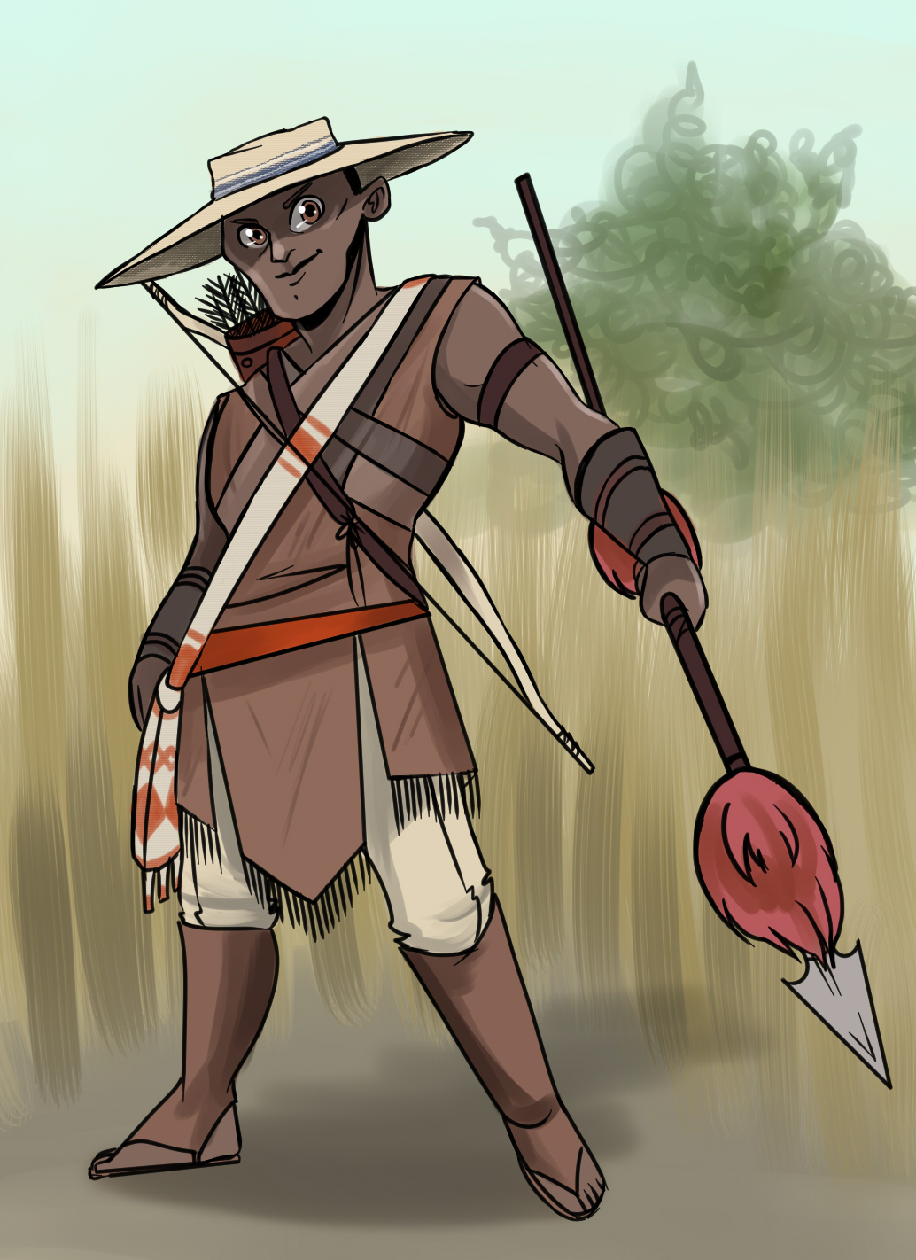
Impending Doom. Destruction (the lifeless body of Egaric in the snow, stabbed in the heart, with a cut upon his palm—as from a crystal shard)
The Grotto of Cascades
Type: Enchanted Place
Impulse: To enchant, bedazzle, and entrap
Description: A rocky ravine in the side of a hill, roofed by ice, and filled with tiered pools linked by icy waterfalls cascading down along the hillside. The water is gelid and clear, and the sounds of water flowing under the ice produce strange gurgling echoes. Spirits are trapped here, mainly Elvish wanderers who’d lost their way and stumbled into the Grotto. The taint of the Usurper Quilthaneil has corrupted many of these spirits, so that they are filled with malice.
- Blind or dazzle as sunlight is refracted through ice
- Produce icy doppelganger from reflection in magical pool which acts with evil purpose
- Give way beneath feet to drop into icy waters, or cause to slide along frozen surface
Grim Portents
- Ice creaks and groans as you move across
- Strange gurgling echoes sound like pleading voices
- Ghostly images appear in the ice, like trapped souls
- An icy doppelganger appears, trying to replace you (see below)
Treasure: A crystal shard, multi-faceted and sharp-sided, radiant in the light. Weight 0, 50 coins.
Impending Doom: Usurpation (a soul is trapped in the ice of the Grotto of Cascades)
Custom Moves
When you search for treasure in the Grotto, roll +WIS. ✴ On a 10+, choose three. ✴ On a 7–9, choose two.
- You find something.
- You suffer no mishap while searching.
- You are not ensorceled by the magic of the Grotto.
When you try to leave the Grotto, roll +WIS. ✴ On a 10+, you find the exit. If you are leading the way, those who follow you take +1 forward on their rolls. ✴ On a 7–9, you find a way out but lose something as you scramble through it. ✴ On a miss, you do not find the exit or you do but bring something undesirable along with you. If you are leading the way, those who follow you take −1 forward on their rolls.
Icy Doppelganger
Your icy doppelganger is as powerful as you are, and is hard to distinguish from you save by its icy cold touch and its opposite handedness. If it manages to kill you, you are now playing your icy doppelganger. It will join the party if permitted and adventure along with them until it reaches a place where the temperature is above freezing, at which point it will begin to melt. Since your icy doppelganger is a mirror image of you, look at your Bonds and invert them (e.g., “___ owes me their life” becomes “I owe _____ my life”); also, change your alignment to its opposite.
Impulse: To slay you and take your place
- Be mistaken for you
- Pervert or betray one of your Bonds
- Use one of your moves
Stakes
- Will Egaric be rescued from the clutches of the orcs?
- Will Turibar be able to bring crystal shards to Aniamadan?
Adventure Front: Ritual of the Frost Crown
Description and Cast
Long ago, an ancient silver elvish sorcerer-king named Dosdaemon raised a high tower in the forests of the North to quiet the Frost Spirits—the jotyna—that brought endless winter upon the land. With the mystic power imbued in the tower’s very stones, he battled the jotyn queen and removed her heart, a diadem of diamond-like crystal. Now a path to the Tower has been opened by a silver elf sorcerer, who will conduct an arcane ritual there that could spell doom for the Forest Strongholds! Alerted to the danger, the adventurers make their way across the Fangs of Ice, into the vale of the Tower, and into the Tower of Dosdaemon itself to confront Aniamadan before he can command an army of ice-spirits to do his bidding.
- Aniamadan (an YOM uh don), silver elf sorcerer
Dangers
Aniamadan, Silver Elf Sorcerer
Type: Arcane Enemy
Impulse: Amass magical power
Description: A brooding figure in black robes ornamented with stars. He has wild white hair and pale blue eyes that flash with cold hatred. He is the long-lost son of King Orcalamun—Dosdaemon’s descendant—and has seen the rise of the Forest Strongholds and the diminishing of his people with regret and loathing. He hopes to bring about a restoration of the Sundalvan (silver elf) people to their rightful place in the land of the North, regarding mortal men as interloping vermin to be driven out or eliminated from the Kingdom of Valienalla.
Solitary, Magical
Staff (d4 damage), Magic Missile (2d4 damage) 15 HP 2 Armor
Far
- Cast potent spell
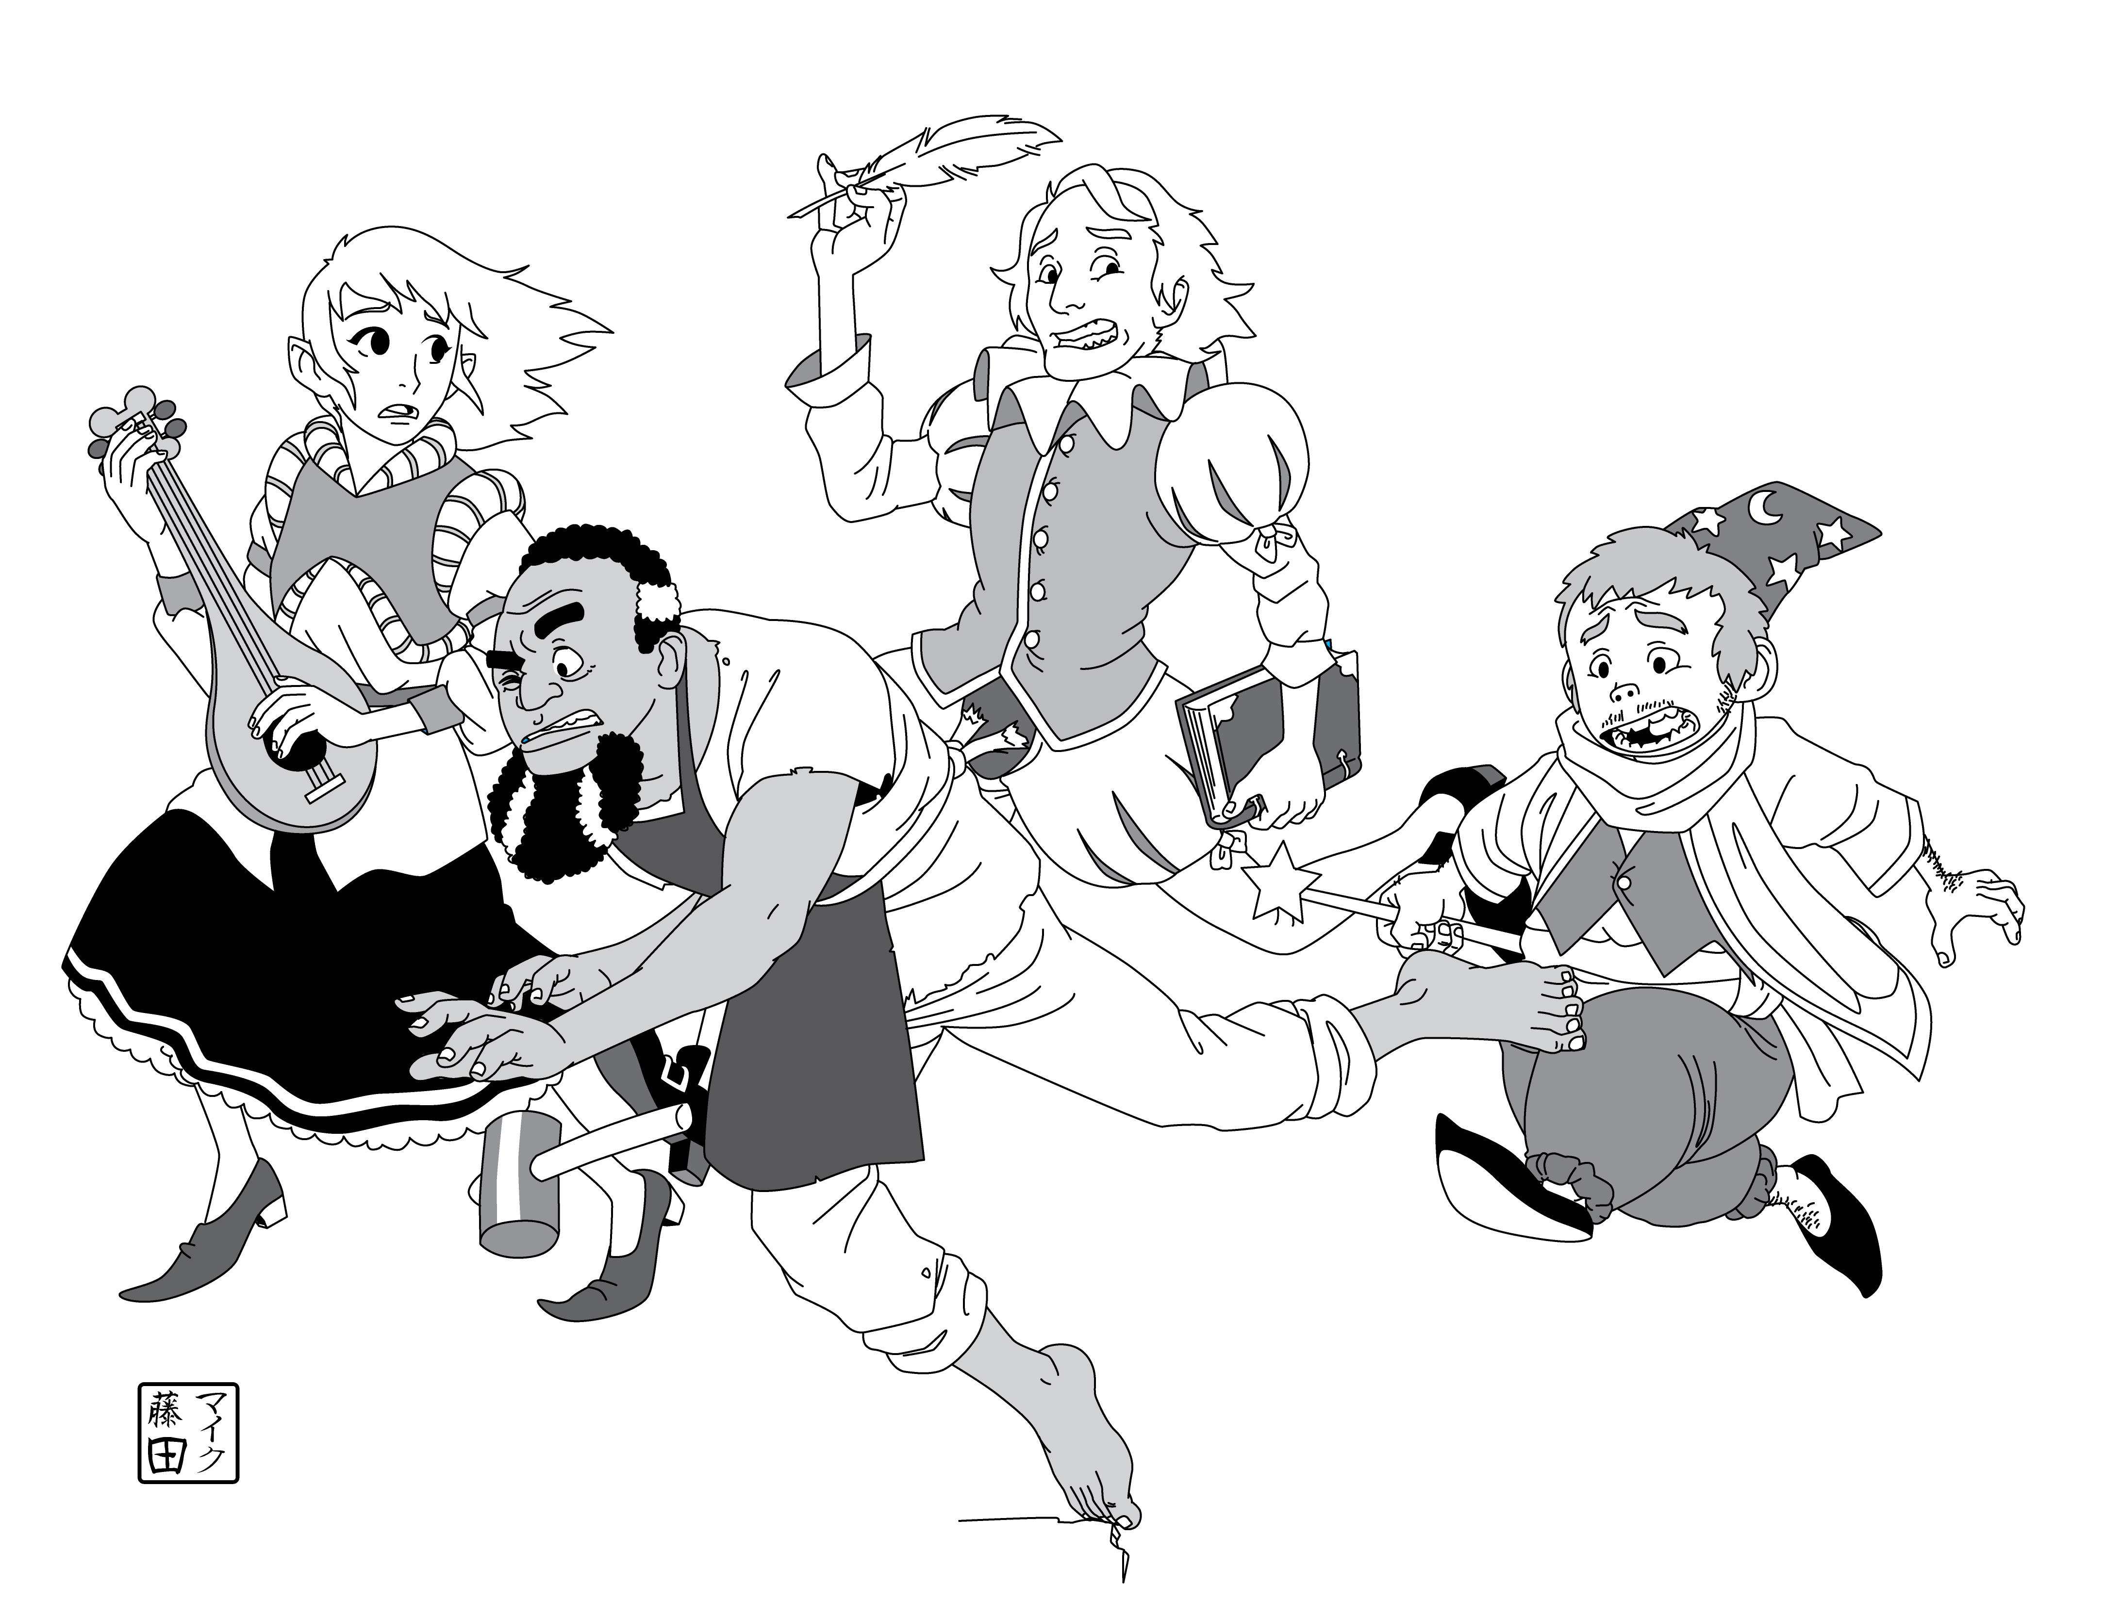
- Read signs and portents
Grim Portents
- Aniamadan crosses the Fangs of Ice to the Vale of the Tower of Dosdaemon
- Aniamadan ascends the Tower of Dosdaemon, leaving orcish minions behind to waylay pursuit
- Aniamadan magically crafts the Frost Crown at the Tower’s summit
- Aniamadan dons the Frost Crown, calls forth the jotyna, and binds them to his will
- Aniamadan succumbs to the malicious spirit of Quilthaneil the Usurper
Impending Doom: Destruction (glaciers flow south, crushing the towns and cities of the Forest Strongholds)
Treasure: Key to the Tower. An ornate key of moonsilver (mythril). 500 coins, 1 weight. The possessor of this key may command the gargoyles of the Tower, and cause its main door to open, close, or lock.
Treasure: The Frost Crown. A silver coronet set with jagged diamantine crystals. 1000 coins (only 500 coins if Turibar has not brought the shards from the Grotto to Aniamadan), 1 weight. Add 1d6+3 to your Charisma while you wear the Crown (only 1d4 if Turibar has not brought the shards).
- Glitter alluringly
- Exude the Usurper’s taint
Custom Moves: These apply to anyone who is wearing the Frost Crown, or could be conceivably said to possess it, or who badly desires it.
When the Frost Crown exudes the Usurper’s taint, roll +WIS. ✴ On a 10+, you resist the Usurper’s taint. ✴ On a 7–9, either change your alignment to Evil or confront the Usurper. If you are already Evil, you resist the Usurper’s taint. ✴ On a miss, confront the Usurper.
When you confront the Usurper, roll +CHA. ✴ On a 10+, your will is superior. Hold 1d10. Spend hold to cast any spell, one hold per spell level. ✴ On a 7–9, the struggle is evenly matched; if you take −1 forward to confront the Usurper, gain 1d4 hold as above. ✴ On a miss, the Usurper’s will is superior: obey his command!
Crossing the Fangs of Ice
Type: Perilous Journey
Description: A crevasse in the ice leads upward, winding through the glacial Fangs of Ice. Possible perils include avalanche, rock fall, collapsing paths, sink holes, and attacks by monstrous Yeti (treat as an ogre) or Aniamadan’s orcish minions (use the stats for Turibar’s orcs). The trail leads through the glaciers to a small circular vale filled with pine trees. In the center of the vale a tall tower of smooth black stone, at least 120’ high, is set amid a vast pine arbor against a glacial backdrop, rising to a machiolated roof. (If you imagine that Aniamadan has already reached the top of the tower, add that something gleams at its pinnacle.)

The Tower of Dosdaemon
Description: The walls are pierced by a ring of arched openings a quarter of the way from the top; there is another similar ring of openings a quarter of the way from the bottom, at least 30 feet from the ground. Between them, a spiral staircase winds around the outside. At ground level, a large, heavy double door of thick iron-bound wood ten feet high prevents entrance (to the Grand Hall at 1., below).
Aniamadan may fire magic missiles at the adventurers from the rooftop if they attract his attention on their approach before returning to his ritual.

1. The Grand Hall
The doors may be forced open with might or magic. Aniamadan will deploy orcish minions within the Grand Hall to waylay pursuers or anyone else who seeks to interfere with his plans. This is a good place to begin a running battle, with the orcs slowly retreating through the interior of the Tower.
This large circular chamber is about 60’ across. It is illuminated by a silvery globe hanging from the ceiling that glows like the moon. The chandelier hangs 40’ above the floor, and swings in a gentle circle. A circle of slender columns provides support for an annular gallery that circumscribes the chamber; another gallery sits above that one. The effect is to create a three-tiered circular chamber with a wide open area at its center.
At the far side of the chamber, across from the door, the wings of a marble staircase with a wide balustrade arc gracefully upward to the lower gallery level; the sigil of the Horned Kings (an ovoid half-white and half-black, with stylized silver antlers projecting from it) is displayed prominently upon the solid front of the staircase, whose landing forms a kind of proscenium projecting out from the lower gallery level (i.e., the landing where the twin stairs leading up from the ground meet could conceivably be used as a platform from which to address a throng assembled below).
An eerie low whistling noise comes from high above (this is the wind blowing across the openings of the upper gallery).
A concentric set of paired columns on the lower gallery supports the upper. Three sets of lattice-like stairs lead up from the lower to the upper gallery at regular intervals (at 3, 6, and 9 o’clock, taking the grand staircase up from the ground level to be at 12 o’clock). There are sconces for torches along the walls, but it is dark in the recesses of the lower gallery.
The walls of the upper gallery are pierced by open arched doorways that lead to the outside (i.e., the Exterior Stairway) at 2., below. Fierce winds blow through the archways, producing a howling sound loud enough to interfere with normal speech (this is the whistling that can be heard from below). The winds are strong and variable enough to throw an incautious adventurer off-balance. A spiral staircase of wrought iron (positioned at 12 o’clock) leads up to the interior of the tower (specifically, to the Library at 3., below).

2. The Exterior Stairway
Description: This staircase winds around the outside of the tower, leading from the upper gallery of the Grand Hall (at 1., above) to the High Gallery (at 5., below). At intervals along the stairway crouch ugly stone statues of winged monstrosities. They will not attack Aniamadan, since he bears the Key of the Tower and is of the blood of their creator, but adventurers and orcs should be wary.
Gargoyle Horde, Stealthy
Claw (d6 damage) 3 HP 2 Armor
Close
Special Qualities: Wings
Instinct: To guard
- Attack with the element of surprise
- Take to the air
- Blend into stonework

3. The Library
Description: There is a musty smell here, and the wooden floor creaks ominously beneath your weight. The walls are lined with shelves filled with books, and several wooden ladders lean against the stacks. The center of the floor is filled with rows of scriptorium desks and benches, with tall standing candelabra among them. A single larger desk faces the scriptorium; a tattered tapestry hangs behind it. You can see pots of ink, quills, parchment rolls, and bookbinding tools and supplies scattered about. There are two large stone fireplaces opposite each other, aligned at right angles to the line between the master’s desk and the scribes’. The spiral staircase from the upper gallery of the Grand Hall (at 1., above) comes up behind the master’s desk; another spiral staircase ascends from behind the scriptorial desks. Light comes from narrow windows set high in the walls. The fireplace flues are small enough to admit a halfling or a goblin, and lead up to the roof (at 6., below), opening amid the spiky machiolations on the roof.
Treasure: A magical quill pen made from a bright gryphon feather that will transcribe what its owner says, as long as the owner speaks in Elvish. Worth 250 coins, 0 weight.

Custom Moves
When you search the library for valuable books, roll +INT. ✴ On a 12+, you have found a book with a magic spell recorded in it; tell the GM the name of the spell and he will tell you what level it is. It is worth 100 coins per spell level. ✴ On a 10–11, you have found something really worthwhile, worth 4d6 coins and 1 use of a book (see Dungeon World p 326). ✴ On a 7–9, you have found an interesting old volume, worth 2d6 coins to a collector. ✴ On a miss, the book is worthless and you have wasted valuable time.
Treasure: A slightly tattered tapestry bearing an ancient Map of the North, before the Fangs of Ice took half the land, with the location of the ancient capital city Taravien marked upon it. Worth 50 coins (more to a sage or a collector), 3 weight.

4. The Chapel
At equal intervals around this room are six statues surrounded by unlit candles. All but one of the statues has been knocked over—that of Anuris.

Custom Moves.
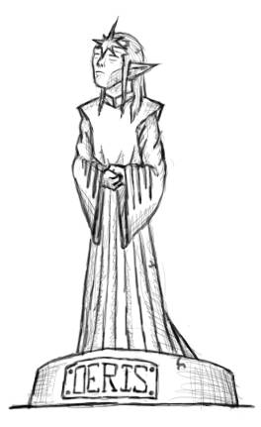
When you light a candle and pray to an upright Lord or Lady, roll +WIS. ✴ On 10+, take +1 ongoing to the particular move favored by the Lord or Lady until the end of the adventure, and mark experience whenever you make that move. ✴ On 7–9, take +1 ongoing to the particular move favored by the Lord or Lady until the end of the adventure, but you owe the Lord or Lady service. ✴ On a miss, take −1 ongoing until you have pleased the Lord or Lady.
- OERIS, Seelie King (an elven elder in royal robes, with a starburst on his brow). Discern realities.
- ANALLA, Faerie Witch (a dancing elf-maid with a wand). Cast spells.
- ANURIS, Winged Eater of Souls (an elf with angel’s wings and devil’s horns, and long fingernails). All moves, but only if you are Evil, otherwise you take −1 forward no matter what.
- OCARON, Prince of Night (an elf cloaked and hooded, with a dagger in his hand). Defy danger.
- RAHN, Piper at the Gates of Dawn (a satyr with syrinx). Hack and slash.
- CARANA, Lady of Swords (an elf-maid in armor bearing a sword before her). Defend.

5. The High Gallery
Description: The external stairway (at 2., above) leads up to a walkway that circles the exterior of the tower. The tower walls along the walkway are pierced at regular intervals by open archways that lead into a high-ceilinged gallery whose floor is a tile mosaic depicting scenes of elvish history. However, the mosaic is obscured by scattered clumps of gauzy white matter of some kind. A spiral staircase emerges from the center of the floor (up from 4., above) and continues up through the ceiling to the roof (at 6., below); a trapdoor bars the way. There is a round dais with something like a circular altar upon it. Clinging to the ceiling of the high gallery like snowdrops are frost bats, white-furred giant vampire bats.
Frost Bats
Horde
Bite (d3 damage) 2 HP
Hand
Special Qualities: Wings; Weakening bite
When disturbed, these white-furred rodents screech scarily and fly around in crazy, erratic patterns.
Instinct: To flee danger or disturbance
- Knock things over
- Cling to someone
- Suck blood
Treasure: The white matter is frost bat guano, valuable to alchemists for the crafting of ice-bombs and similar potions; it’s worth 3 coins per unit of weight collected, but scraping it up may disturb the bats.
Treasure: Resting upon the altar is a silver wirework sculpture, vaguely bowl-shaped (300 coins, 2 weight). Tiny crystalline shards are scattered like dust across the top of the altar; they can cut someone who’s careless.
Treasure: 1d6 immature frost bats, capable of being trained as familiars or message-carriers, each worth 25 coins, 1 weight.

6. The Roof
Description. A ring of jagged machiolations, like fangs, surrounds the edge of the roof. Access is via a trapdoor that leads to the High Gallery (at 5., above). The land is spread out below, all pine forests and snow, with gigantic glaciers in the distance surrounding the vale of the tower. From here, it is possible to fire missiles at those below. A circular mosaic is laid in the center of the roof; it is a magic circle circumscribed with ancient Elvish runes of protection and power.

Custom Moves.
When you step into the magic circle and call the jotyna, roll +CHA. Regardless of the roll, 1d3 jotyna appear. ✴ On a 10+, they are bound to heed your wishes. ✴ On a 7–9, they demand something from you; if you accede, they are temporarily bound to your will. Otherwise, they are unbound. ✴ On a miss, they are unbound and hostile.

Stakes
Can the Frost Crown truly be controlled?
Will the Forest Strongholds be destroyed by ice?
Will the Usurper rise again?

Notes for the Game Master
The flow of the adventure is imagined to be something like this: the PCs begin the game in mid-blizzard, taking action in the face of immediate needs for warmth and shelter. The plights of Rurik the dwarven merchant and Egaric the noble youth come to their attention, as does the presence of the trio of frost spirits, working their ice magic to the despite of living things. They will see signs of Turibar and his orcish minions as well. Dealing with those exigences should lead to the Grotto of Cascades or, at the very least, to the trail to the Tower of Dosdaemon. After a perilous journey across the Fangs of Ice, they approach the Tower. Should Aniamadan become aware of being followed, he will deploy his minions to deter, delay, and defeat them; his own goal is ever forward, to the top of the Tower of Dosdaemon! There he will complete the crafting of the Frost Crown and call the frost spirits once trapped within the Fangs of Ice. If the PCs don’t stop him, Aniamadan’s evil plan will see glaciers rolling inexorably southward through the Forest Strongholds, crushing the human communities in their path and leaving Lake Silverweir surrounded by ice. The intent is that you use the Tower of Dosdaemon as the backdrop for a running battle against Aniamadan and his minions, but it is sufficiently detailed that the PCs can dungeon-crawl through it should the threat of Aniamadan lose its urgency. Its major sources of menace are the gargoyles around its exterior and to a lesser extent the frost bats within.

Extracts from Stone & Shadow
An article by Chris Sakkas
Introduction
I was delighted to see John Harper recently re-release World of Dungeons, his 1979 magnum opus, for the Dungeon World Kickstarter. It brought back a lot of fond memories of gaming and writing during the 1980s. Everyone who played during that time bought Stone & Shadow, the unofficial World of Dungeons magazine. During that decade, it was the only content available while John Harper worked feverishly on Advanced World of Dungeons. Despite repeated promises, the expanded game (five pages, not including character sheets!) never materialised.
Though the magazine was unofficial, it became as important to players as the official rules themselves. The clarifications of and expansions upon World of Dungeons in the rules advice column ‘Harper’s Bizarre’ were controversial but very popular.
Of course, Stone & Shadow was a product of its time. Many of its classes, monsters and other content were clearly lifted from the popular culture of the day. In that, though, it loyally followed the World of Dungeons tradition.
On this, the release of a Dungeon World zine, it seemed fitting to harken back to the mythical foundations of our hobby. I hope you enjoy this blast from the past—extracts from Stone & Shadow issue 1!
Chris Sakkas.
Rounding out the Classes
[With errata reported by Christopher Weeks. — CS]
The original World of Dungeons presented nine skills and just five classes. Even with the Cleric doubling up with Heal and Decipher, that leaves three skills without a class to accompany them. If you follow the recommendation in this issue’s Harper’s Bizarre [to remove the Decipher skill from the Cleric. —CS], that’s another skill that should be the chosen skill of a class.
This article corrects this fault by presenting the Mountebank (trained in Deception), the Psychic Knight (trained in Awareness), the Archer (trained in Leadership) and the Archaeologist (trained in Decipher). These four classes rounds out the skill list; there is no need for any more classes to be written and Stone & Shadow will not publish any more. [This proved a little ambitious. By my count, S&S had published 134 classes by the end of its run. —CS]

Psychic Knight
The Psychic Knight is in tune with the universe. [Guess which popular sci-fi movie had recently been released. —CS]
Skill: Awareness.
Abilities (choose two):
Soulblade: You can summon a martial weapon using the power of your mind. It ignores Armour.
Deflect Attacks: You have an energy shield that takes damage equal to 2d6 before dissipating until you next rest.
Suggestion: You can change people’s memories with a wave of your hand.
Telekinesis: You can move and throw objects with your mind.

Mountebank
The Mountebank is a trickster and a charlatan who profits immensely from his or her frauds.
Skill: Deception.
Abilities (choose two):
Feign Ability: Roll +CHA. On a full hit, you gain the ability of another class for a whole day. On a partial hit, it fails you at an inopportune time.
Snake Oil: When you apply snake oil to an unwitting target, it has the effect the target believes that it has—but only for a short time. (In the case of a death effect, the target sleeps and cannot be awoken during the time).
Escape Notice: If there is anything else of equal or greater interest around you, you cannot be detected.
Gambit: Roll +CHA. On a full hit, you have perfectly prepared for this situation.
The Greater Fool: You always recognise the deceptions and schemes of others.

Archaeologist
The Archaeologist investigates the past with a weapon in one hand and a culturally significant artifact in the other.
Skill: Decipher.
Abilities (choose two):
In the Library: When you use Decipher to use a magic item or ritual you have discovered, you learn one fact about its history or creation.
Outta the Library: When you roll 6 or lower on a Lore or Decipher roll, you learn one entirely unrelated fact.
Orbis: You ignore the presence of the divine and the profane in any circumstances where they would cause you difficulties.
Iconic Style: Any time you roll a 1 on your damage die, your enemy suffers another effect, like being knocked prone, entangled or knocked back a few feet.

Archer
The Archer has a mysterious power over the world. [I believe Diana Wynne Jones’ 1984 novel Archer’s Goon was the inspiration here. —CS]
Skill: Leadership.
Abilities (choose two):
Goon: You are twice the size of a normal person. When you roll HD, roll an extra 1d6. If you roll a 1 on damage, reroll.
Domain: Choose an area of the world, like the sky, or plants, or the future. You have natural power over that area.
Command: You can order creatures and people related to your domain to do your bidding. Requires: Domain.
Iron Will: You never suffer from mind-affecting effects.

The Truenamer
Skill: Decipher.
Abilities (choose two):
Words of Power: You begin knowing two words of power (see Truenaming).
Call Back: You can bring back from the dead anyone whose truename you know. On a miss, your shadow parts from your body and could fall under the influence of a Wizard with the Shadow cantrip.
Animal Form: You can transform into an animal by speaking its truename. The longer you remain transformed, the greater the risk of losing your mind. You know the truenames of at least a couple of animals.
Improvise Word of Power: You can speak a word of power that you do not know. On a miss, you can never speak it again.
Slave: If you know someone’s truename, you can control their body and mind.
Truenaming: Truenaming requires speaking words of power. A Truenamer begins knowing two words of power (nouns or verbs). Speaking a verb forces a target to take that action or causes an object to take that action (‘float’, ‘sleep’, ‘speak’, ‘dance’, ‘burn’, etc.) Speaking a noun gives control over those things or gives an area or object a quality related to that noun (‘truth’, ‘raptors’, ‘weapons’, ‘sky’, etc.)
Just as a Wizard can bind more spirits, Truenamers can learn more words of power. The more specific the word, the more power the Truenamer has over its subject.
Alignments
Each character chooses one alignment.
Lawful
Respect the gods and obey the laws of the universe.
Chaotic
Defy the gods and the natural order of things.
Neutral
Actively balance Law and Chaos.
Wealful
Do good and act selflessly.
Woeful
Do evil and act selfishly.
Unaligned
Look out for yourself and those you care about.

Old
Maximum speed: Normal. An extra skill. Cannot get an extra HD for being attended by a healer.
Wounds
When reduced to 0 HP or below, you take a wound. The GM rolls the die of fate. On an even result, the injury is superficial (heals during your next rest). On an odd result the injury is major. While wounded, take −1 forward on all relevant rolls and:
- Leg wound: SPD drops by one class.
- Arm wound: Cannot use that arm.
- Torso wound: Don’t add CON to HD.
- Head wound: Cannot use any skills.
The Die is Cast: Random Encounters
Another use for the die of fate.
[Note that these place names names are taken from World of Dungeons, and are not covered by the Creative Commons licences that otherwise apply to this compilation. — CS]

Uru and the Great Desert
- Sandstorm.
- Sandworm.
- Dead horse and rider.
- Band of lion hunters.
- Oasis.
- Lost city.

Northlands
- Fiery-hearted tundra wyrm.
- Injured werebear.
- Warm springs.
- Herd of yaks (one talking yak).
- Northish traders.
- Repentant berserker.

Xanathar and Islands
- Linnorm.
- Sacred baboons.
- Circus troupe.
- Philosopher-knight.
- Giraffe-centaurs.
- Amber pyramid.

Imperium
- Nomadic raiders.
- Mirage.
- Officious mamluk.
- Zealot on a mission.
- Prince on a flying carpet.
- Genie’s lamp.

Ankhyra and Cythonis
- Priest of the Sun and Moon.
- Giant frog.
- Cythoni agitator.
- Ankhyran enforcer.
- Barrow.
- Floating vineyard.

Regency
- Ghost of Old Ironsides.
- Green giant.
- Cavaliers.
- Roundheads.
- Woodwose.
- Fay.

World of Dungeon Crawls
An article by Chris Bennett
Survival & Silver won by Sorcery & Sword
Rules for 0-Level Characters
Starting off with characters who are 0-level is an interesting challenge. Most will die in their first dungeon. For obvious reasons, it is recommended that each player take 2–3 characters.
Those few who survive will be able to choose a class and become 1st level characters.
Character Creation
Roll Attributes as in World of Dungeons.
Roll 2d6, discard the higher and use the other as your HP. You may re-roll the dice a number of times equal to your CON before discarding.
Determine your Occupation.

Dice | 1 | 2 | 3 | 4 | 5 | 6
1 | Beggar | Grave Digger | Urchin | Con Artist | Hunter | Trapper
2 | Slave | Vagrant | Herder | Farmer | Artisan | Trader
3 | Cutpurse | Servant | Animal Trainer | Cobbler | Mercenary | Armorer
4 | Smuggler | Woodcutter | Baker | Locksmith | Astrologer | Minstrel
5 | Gambler | Miner | Herbalist | Scribe | Shaman | Wizard’s Apprentice
6 | Cooper | Blacksmith | Sage | Squire | Alchemist | Noble

Choose a Special Ability that makes sense with your Occupation, such as:
- Sages get Vision
- Locksmiths get Tinker
- Animal Trainers get Pet
- Wizard’s Apprentices get Cantrips
Equipment
Choose one piece of Adventuring Gear. Next, choose an additional piece of gear relevant to your occupation from the list based on a 1d6 roll:
1–4: Tools
5: Occult Items
6: Fancy Items
Weapons
Roll 1d6 and choose a weapon based on the roll:
1–3: Light Weapon
4–5: Martial Weapon
6: Shortbow/Sling (roll 1d6 for the number of arrows, sling stones, etc.)
Wealth
All 0-level characters have accumulated 1d6 SP.
Experience
All 0-level characters start with −100 XP. When your XP reaches 1, you choose a class, get a Skill and an additional Special Ability, and are 1st level adventurers! If you survive, that is …
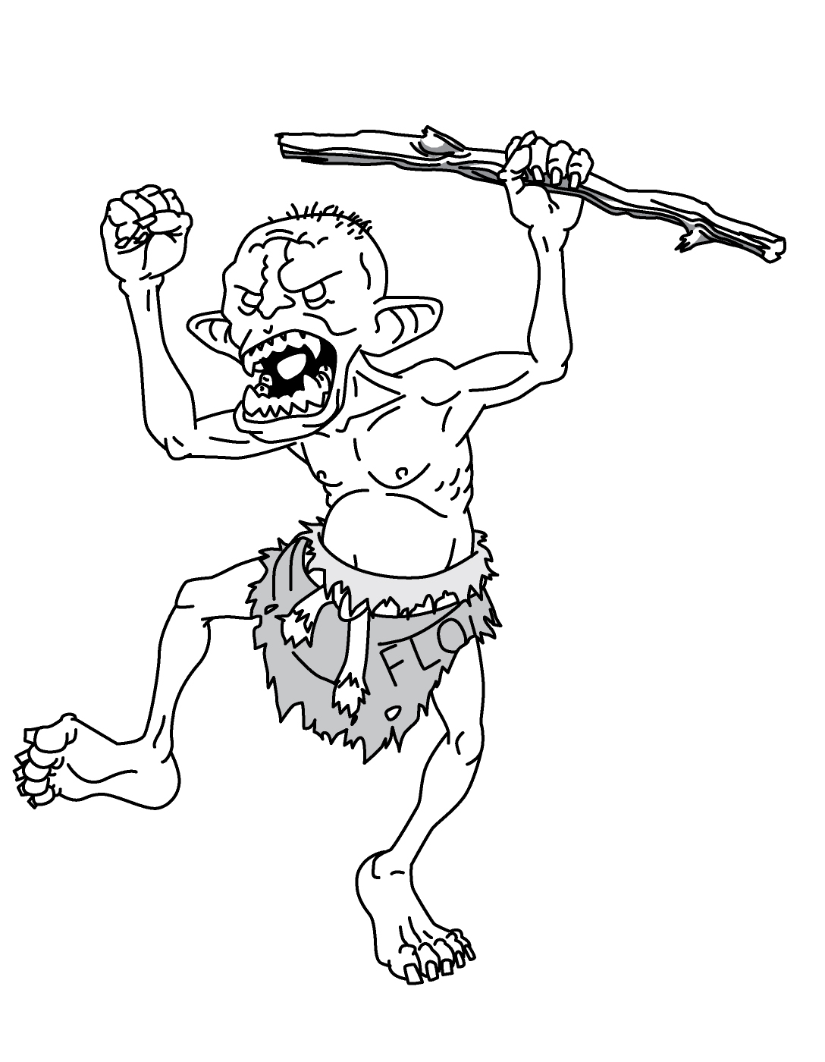

Attribution
Components described as licensed under ‘CC Attribution’ are under the Creative Commons Attribution 3.0 Unported License.
Compontents described as licensed under ‘CC Attribution-ShareAlike’ are under the Creative Commons Attribution-ShareAlike 3.0 Unported License.
All written contributions to Grim Portents and all artworks created especially for this issue are licensed under CC Attribution:
- The squid-mage on ‘The Fourth Page’, the fish-beast on the ‘Monsters’ article and the would-be adventurers retreating from the single goblin on the ‘World of Dungeon Crawls’ article are by Michael Wight. His design and games imprint is Gremlin Legions.
- The wendigo spirit illustrating the ‘Monsters’ article, the Oeris statuette illustrating the ‘Tower of Dosdaemon’ article and the bladeling ranger and tiefling wizard illustrating the ‘Extraplanar Races’ article are by Giovanni Lanza.
- The expedition mounted on a bear and the enraged battle-bear illustrating the ‘Rythbjorn’ article are by Nate Marcel. Check out Nate’s Notes for more.
Other art was taken from Open Game Art, Prismatic Art, Flickr and Wikimedia Commons.
- The icicle illustrated on the front cover was captured by Bruce Guenter (on Flickr). Under the Creative Commons Attribution 2.0 Unported License.
- The skull in the snow illustrating the foreword is by Justin Nichol (on Open Game Art). CC Attribution-ShareAlike.
- The robot warrior illustrating ‘The Engine of Destruction’ is by Nicolas Mina (on Open Game Art). CC Attribution-ShareAlike.
- The spirit shaman illustrating ‘The Necromancer’ is by Shari Chankhamma (on Prismatic Art). CC Attribution-ShareAlike.
- The Vietnamese-inspired fighter illustrating ‘The Warrior’ is by Grace D Palmer (on Prismatic Art). CC Attribution-ShareAlike.
- The vision of Death in the mind of one still living illustrating ‘The Flatliner’ is a public domain image from Weird Tales (on Wikimedia Commons).
- The frostborn illustrating the ‘Templates’ article is a creature from the Ancient Beast game project by Katarzyna Zalecka (on Open Game Art). CC Attribution-ShareAlike.
- The chillspeaker goblin illustrating the ‘Templates’ article was created by mrkrunkles (on Open Game Art), CC Attribution.
- The castle in the icy wild illustrating the ‘Companions’ article and the tower illustrating the ‘Tower of Dosdaemon’ article were created by Toeholds for an art competition (on Open Game Art). CC Attribution-ShareAlike.
- The lion hunter illustrating ‘The Die is Cast’ is Wahab, created by Kaitlynn Peavler (on Prismatic Art). CC Attribution-ShareAlike.
- The fey illustrating ‘The Die is Cast’ is the Dance of Rebirth, created by 5hiroi and released into the public domain (on Open Game Art).
Written and laid out (predominantly) in LibreOffice Writer.
Typefaces: Linux Biolinium O, Linux Libertine O, Narkisim and LilyUPC.

